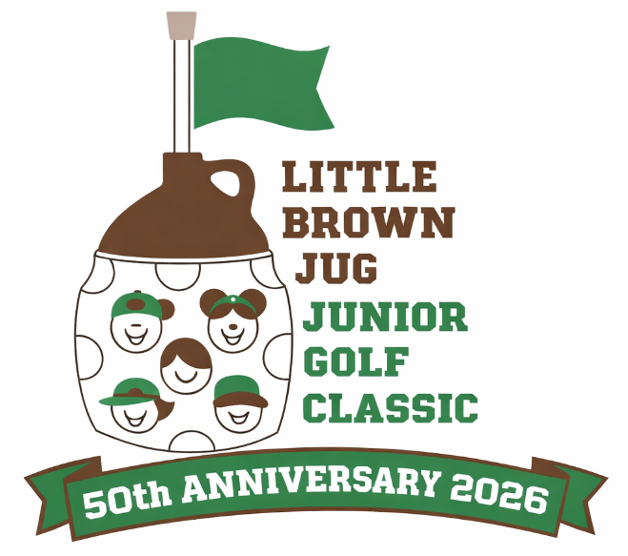
50th ANNUAL LITTLE BROWN JUG JUNIOR GOLF CLASSIC
Presented by the Kiwanis Club of Delaware County

Saturday, July 11, 2026
Hidden Valley Golf Course
One 9 hole round. USGA and local rules apply.
Rain date: The following Saturday (July 18)
No Entry Fee

Age brackets: 7-8 years of age, 9-10 years of age, 11-13 years of age, 14-17 years of age
(please circle bracket above)
Register early as the field is limited to 72 players. Players will be accepted on a first come, first serve basis. Excess applications and checks will be returned to sender. Deadline for registration is July 6, 2026 by mail, email or at Hidden Valley Golf Course.

Registration Form:

Name:_______________________________________________________________

Address: _____________________________________________________________

City, State, Zip__________________________ Phone: (____)___________________

Email address (for T-time):
______________________________________________________________________

Date of Birth: _______________________ Age on 7/11/2026: ___________________

Gender: M _____ F ______

NOTE: NO CELL PHONE USAGE WILL BE ALLOWED DURING THE ROUND. **Also, if you are a member of a school Golf Team, you must ask your coach if you are eligible to participate in this event. Also, we would appreciate knowing if you are not able to play, even though registered.

The parent or legal guardian of participant must read and sign the following:
I, the parent or legal guardian of the above named child, release the Little Brown Jug Junior Golf Classic Committee, the Delaware County Kiwanis Club, the City of Delaware, all volunteers, event sponsors, their employees, agents and officers from any and all liability arising from the above activity.
(Continued on next page)

Page 2
LBJJGC Registration 2026

I understand that no accident, health or life insurance covering the participants in this program will be procured and that my consent to the participation of the above named participant in this program is made with this understanding.

I agree to the use of the above participant’s name and/or photograph in broadcasts, newspapers, brochures and other media without additional approval or compensation. I understand that the entry fee is non-refundable and non-transferable. Inappropriate behavior by a player will result in them being asked to leave the course. I hereby acknowledge that I will not be on the course to accompany my child.

Parent/Guardian Signature: ________________________________________________

This signed form may be turned in to the Hidden Valley Golf Course, emailed (eschlote@gmail.com), or mailed in time to arrive by July 6, 2026 to:

LBJJGC
Edward J Schlote
378 Cool Springs Lane
Delaware, OH 43015

Please note: Parents/friends/relatives will NOT be allowed on the course. This is an event for the kids and not a spectator event. Designated areas will be provided for parents and guests to observe portions of the event. Folding chairs are permitted. Players may carry their own bags, provide their own pull cart, or rent a pull cart from the course, as available. Power carts are NOT permitted.

For questions, please contact Edward Schlote at 740-417-4663 or eschlote@gmail.com

Parents: This is a non-profit event with financial support from the Kiwanis Club of Delaware County and interested businesses and individuals. If you would like to provide additional support of this event, please consider joining the group of LBJJGC volunteers. Any amount is appreciated. Suggested donations are:

Bronze: $10
Silver: $25
Gold: $50
Platinum: $100+

Please let us know if you do NOT want to be recognized publicly for your support. Please send funds to the address above and thank you in advance. All checks are to be made payable to: Kiwanis Club of Delaware County

Also, if you can help out the day of the event by walking with a group your child is not in to assist with scoring, please put your name here: ______________________ (We will make every attempt to put you in the group behind or in front of your child so you can observe from a distance)

