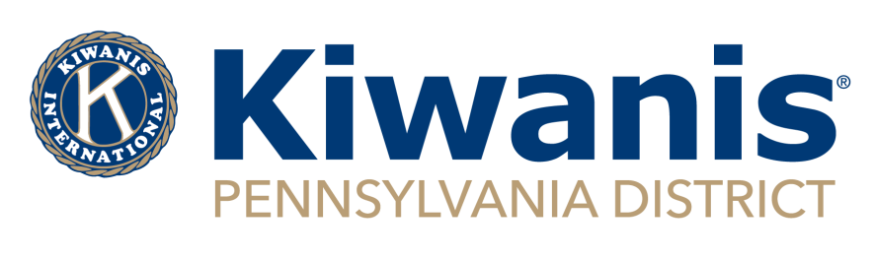
2021-22 PA District
Club Communications Contest
To enter your Club in the communications contest, please complete the information below and return this form along with one example of efforts to share club information to members from at least 3 of the 12 months.
All entries must be received on or before July 10, 2022. There will be 1st, 2nd, and 3rd place recognition based upon membership categories. Winners will be published in the Keystone Kiwanian and listed on the District Website.
Club Membership Categories:
(check one)

Silver Division (46+ members):
_______

Blue Division (25-45 members):
_______

White Division (24 or fewer members):
________
(Attach any hard copies you wish to be reviewed)
LINK: __________________________________________________________________________________
FACEBOOK NAME: _______________________________________________________________________
TWITTER ACCOUNT: ______________________________________________________________________

CLUB NAME: _________________________________
DIVISION: ___________________________________
Editor/Secretary: _____________________________
Email/Phone: ________________________________
____________________________________________
How often do communications with membership get disseminated?

What is your primary means of communicating with Club members?

Please submit all entries to: Awards, PA Kiwanis District Office, 125 North Enola Drive., Suite 206, Enola, PA 17025 or michelle@pakiwanis.org. Please submit via email if possible.
Club Communication Contest (Scoring Rubric)
Membership Category: _______________________________________________________
Club Name: | Includes traditional newsletter or digitally distributed updates regularly | Includes contact information or access to service project participation | Use of social media | Relays useful information or interesting news to members | Promotes and includes SLPs or Key Leader | Includes Divisional, Regional, District and/or International references | Total:
 | 10 | 10 | 15 | 20 | 20 | 15 | 90

Please submit all entries to: Awards, PA Kiwanis District Office, 125 North Enola Drive, Suite 206, Enola, PA 17025 or michelle@pakiwanis.org. Must be submitted by July 10, 2022. Please submit via email if possible.

