**Minisink Valley Kiwanis Mother's Day Flower Fundraiser**

**PROCEEDS TO BENEFIT COMMUNITY PROJECTS**

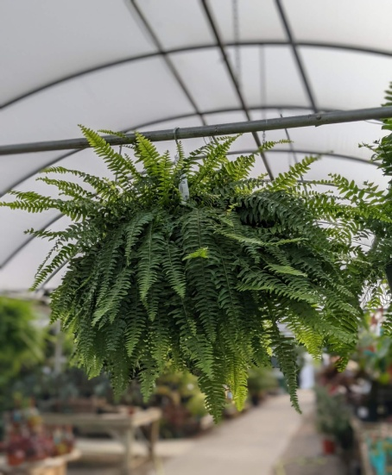 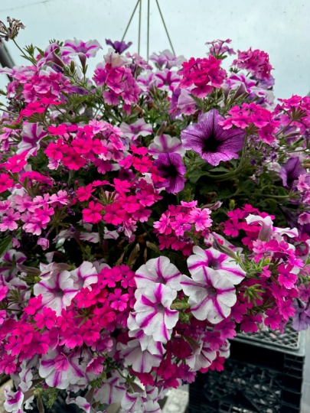 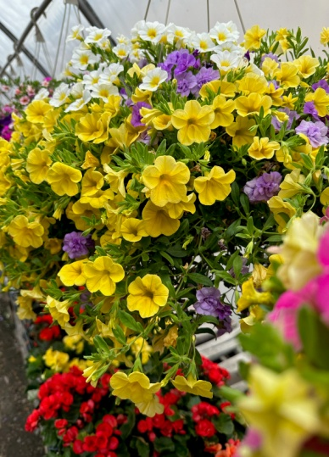

**10"Hanging Ferns $28.00 each 12" Hanging Baskets $32.00 each (assorted variety and color)**

**{These are the large hanging baskets}**

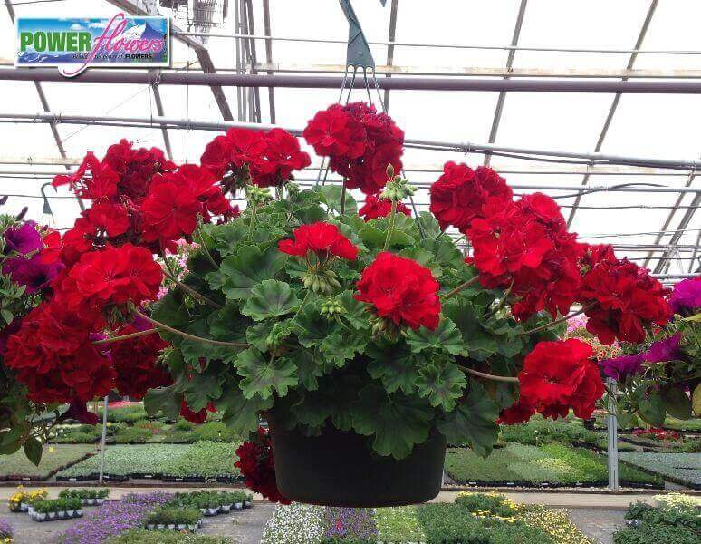 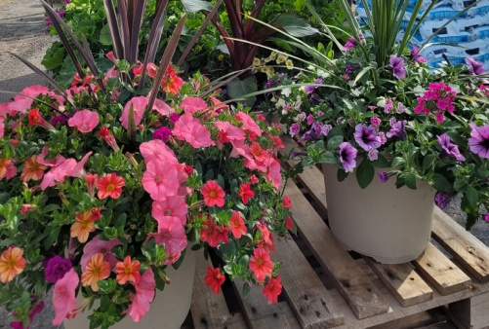 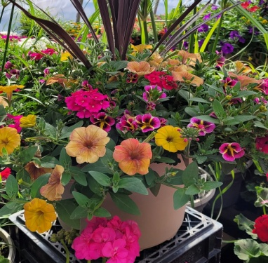

**12"Geranium hanging $32.00 each 14" Deck Pot $40.00 each (assorted variety & color)**

**(Assorted colors)**

**CONTACT ANY MINISINK VALLEY KIWANIAN TO ORDER FLOWERS**

**Order Deadline: Wednesday, April 10th, 2024**

**Order Pick Up: Week of May 6, 2024 – (Date and Time TBD)**

**\*\* Pick up Location - Greenville Town Park \*\***

**\*\* ALL PRODUCTS ARE SUBJECT TO AVAILABILITY\*\***

**\*\*IF NECESSARY, PRODUCTS ARE ALLOWED TO BE SUBSTITUED\*\***

**\*\*DELIVERY DELAYS MAY OCCUR DUE TO UNCONTROLLABLE CIRCUMSTANCES\*\***