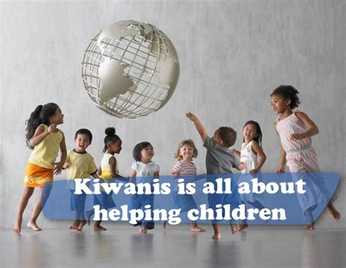
Changing
Times
Changing the World Through Service, Friendship & Fun
Be Our Guest

Kiwanis SEMD Newsletter - December 2025

NEXT MEETING DATE TBD

2025-2026 Kiwanis Club of Southeast Metro Denver

Melissa Schupp President
Gail Coombs Immediate Past
President,
Dave Rich President -Elect
Jack Forhan Treasurer
Lizzie Coombs Secretary
Keith Schupp Director
Lizzie Coombs Director
Mary Forhan Newsletter
Mary Forhan Club History

Committee Heads
Pints & Pinots – 2nd Wind Fundraiser
Gail & Lizzie Coombs – Tentative
Postponement to 2026
Colorado Feeding Kids
Dave Rich, Gail Coombs
Sweet Dream in a Bag
Shavon Forte
Kiwanis One Day – Gail Coombs
Website - Melissa Schupp
Parker Days – Mel & Keith Schupp,
Ronald McDonald House – Jim Terpstra,
Melissa Schupp

Websites
KiwanisInternational http://Kiwanis.org

Kiwanis Rocky Mountain District
https://www.rmdkiwanis.com/

Kiwanis DTC and SEMD
Kiwanissemd.org

kiwanissemd.org

Together we can change the world, one child and one community at a time.

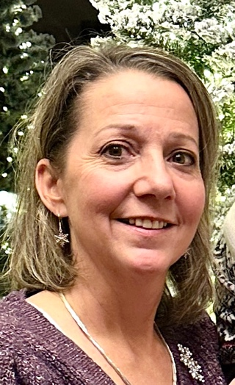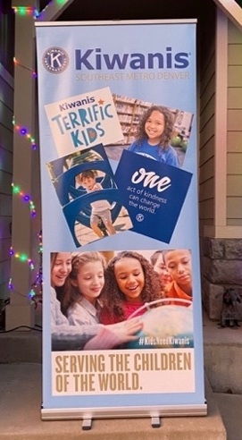
“Be Our Guest”



President’s Message

t was wonderful to see everyone at the Holiday Kiwanis Party! Thank you for making it such a fun and memorable day. The team Christmas Jeopardy game definitely brought out some friendly (and impressive!) competition.
Looking ahead to 2026, we’re excited to continue our work with Colorado Feeding Kids. Keep an eye out for volunteering opportunities coming up in the first quarter. I’m also working on scheduling an event with Clothes to Kids of Denver, where volunteers are always needed to sort donated clothing and assist shoppers in the boutique.
In addition, I’d love for us to volunteer at the Denver Children’s Home—serving breakfast and spending time with the kids through team games like Family Feud, Pictionary, or board games.
If you have ideas for volunteering opportunities, please share them with the board. We’re always open to new suggestions and ways to serve our community.
Happy New Year! 🎉
Here’s to an amazing 2026 filled with meaningful service, strong teamwork, and plenty of fun.
Melissa Schupp

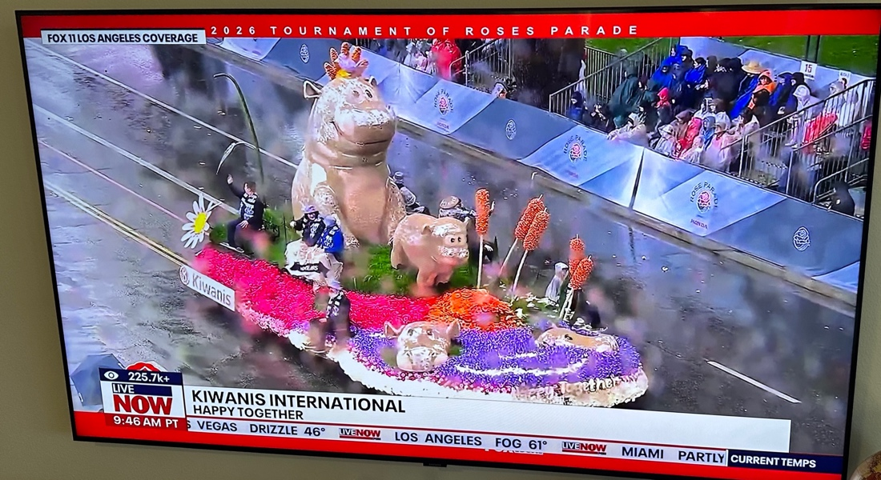
Kiwanis Float at the Rose Bowl Parade

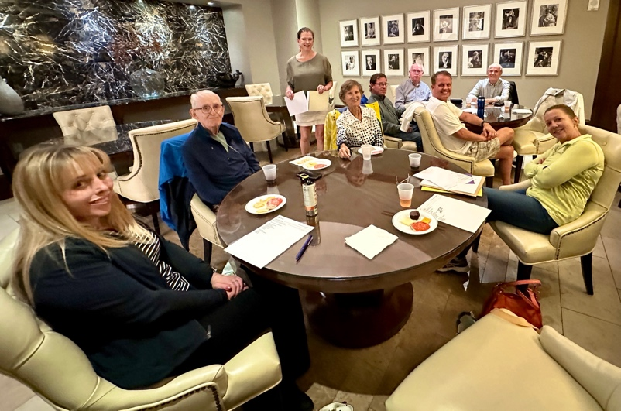

Recent Past Events Thanks to everyone who volunteered

Ronald McDonald House Christmas with Santa! Aurora Location Dec 13
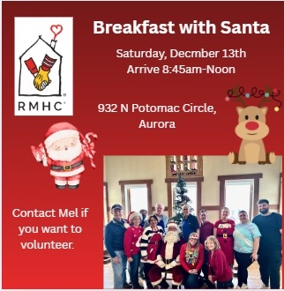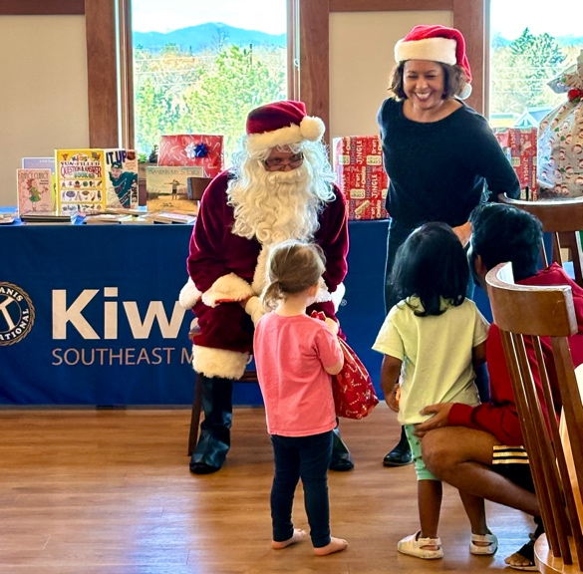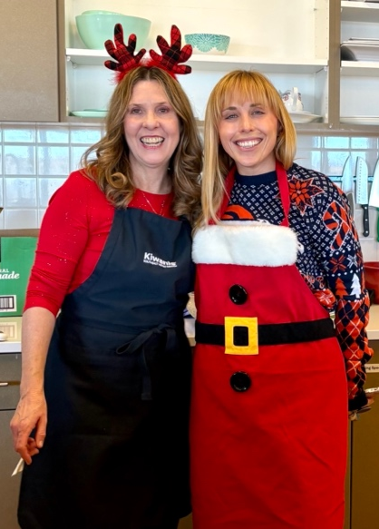

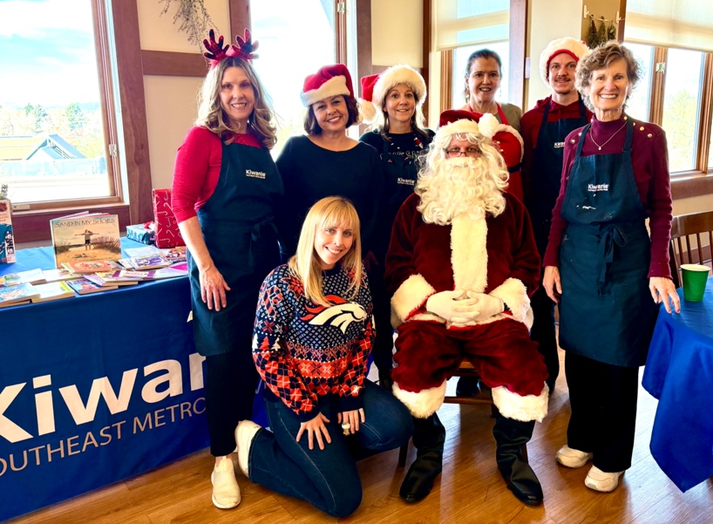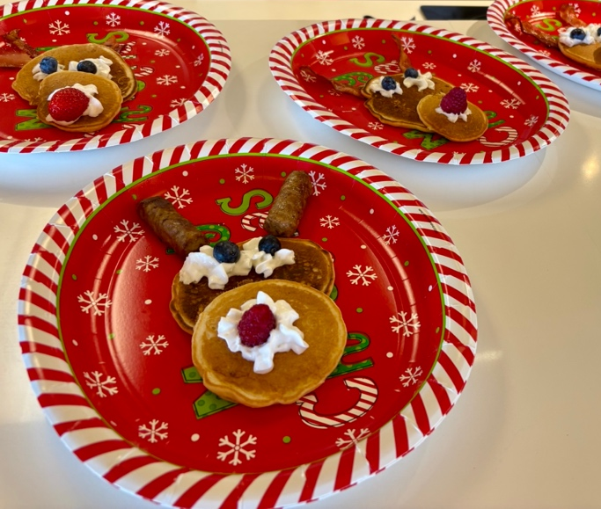

Salvation Army Bell Ringing – Saturday, December 13, 3:30-5:30 Spreading holiday cheer for a good cause - Kiwanis SEMD raised $5l79.88. Outstanding! King Soopers at Orchard and Holly

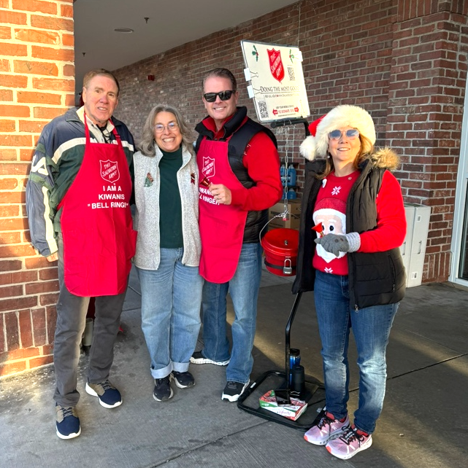
Christmas Party
Thanks to Keith and Melissa Schupp for hosting this fun party!
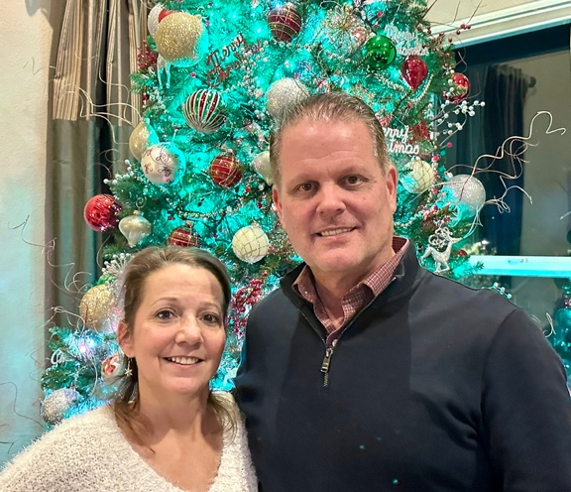

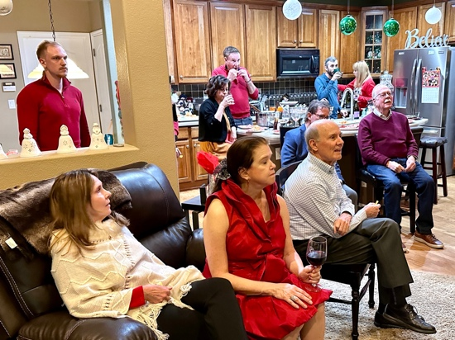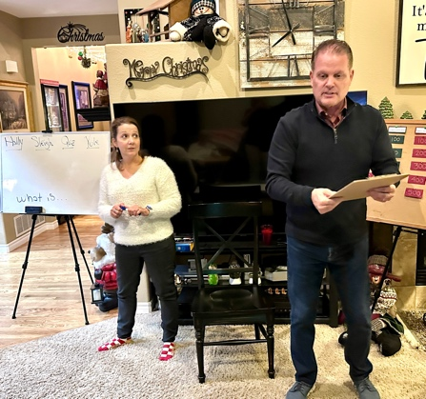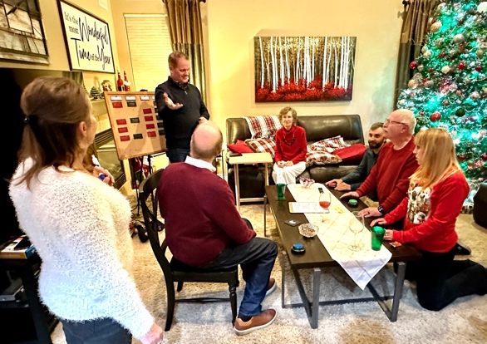
Christmas Jeopardy with extraordinary game hosts, Keith and Melissa who kept the fun rolling!

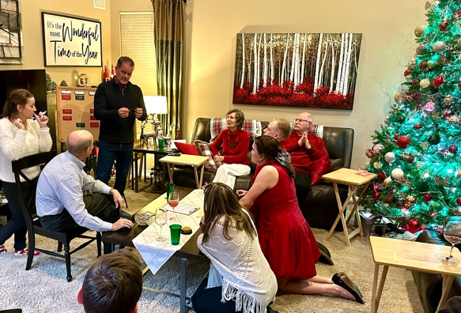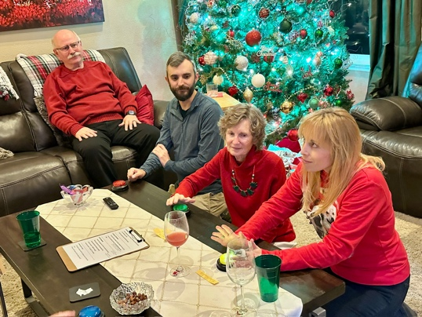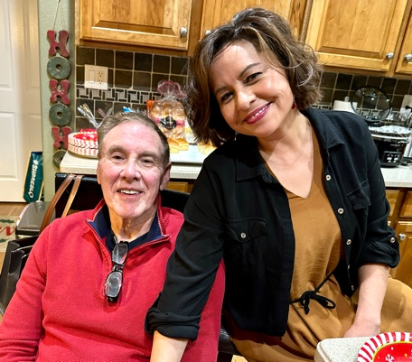
Thanks to all who provided food and drinks. What a feast!

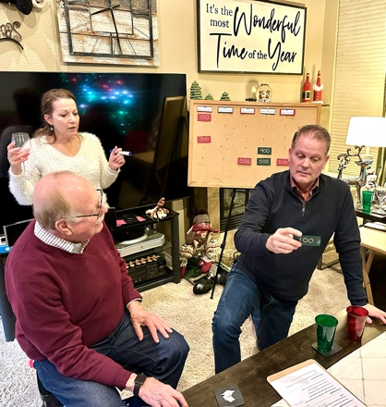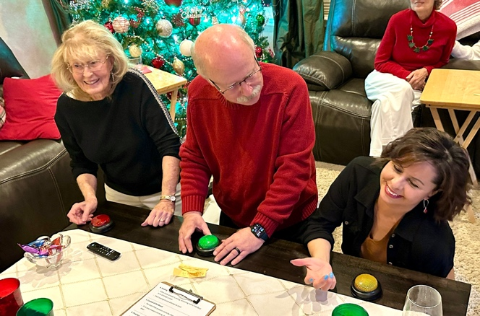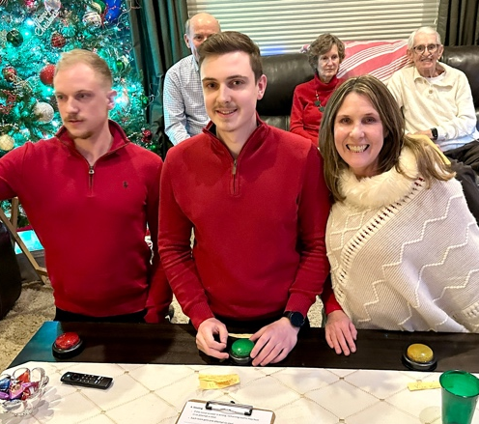

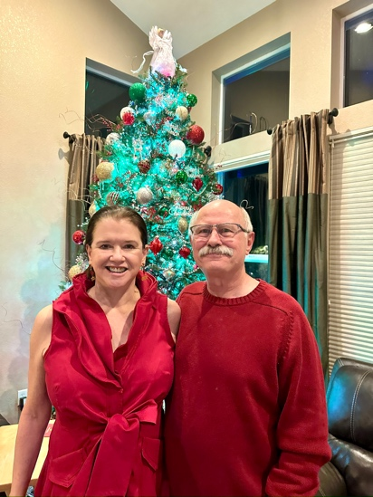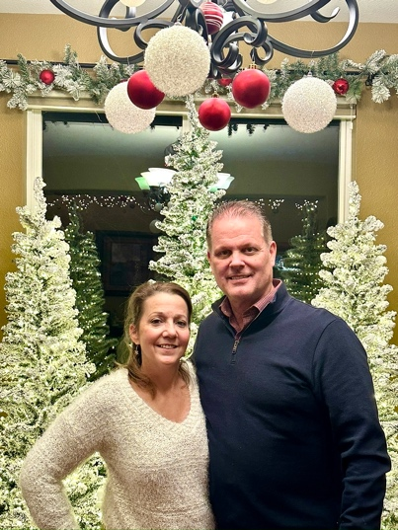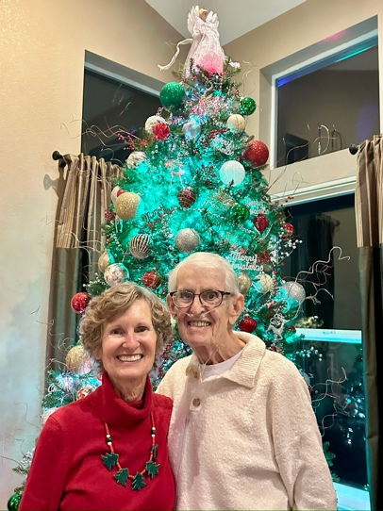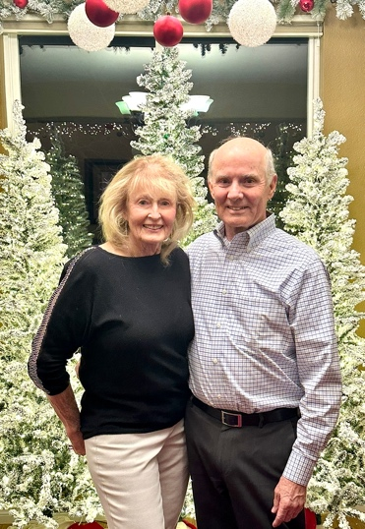

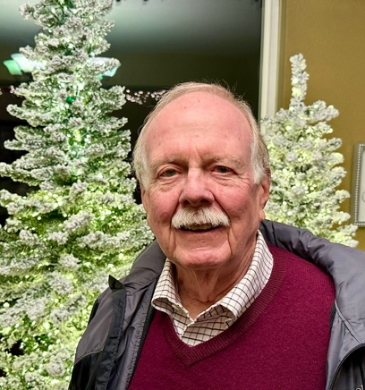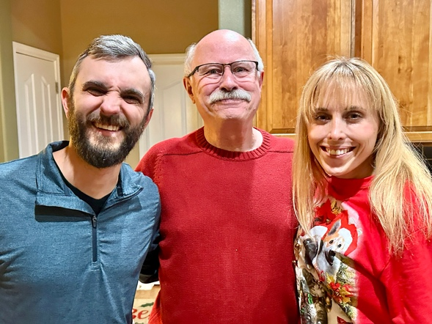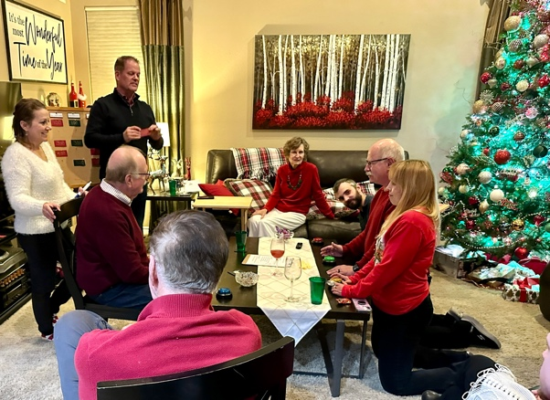

Past social and service in the fall of 2025 – Memories of an autumn of giving.

October Happy Hour - Hello Valuable Volunteers!

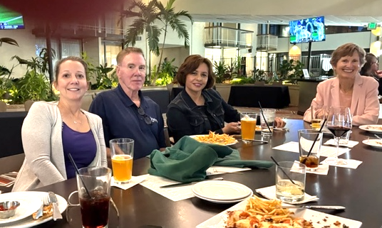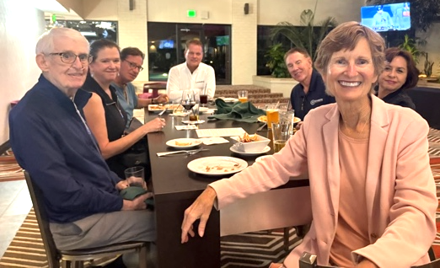

CO Feeding Kids Division Packing Saturday Oct 18 10am-Noon
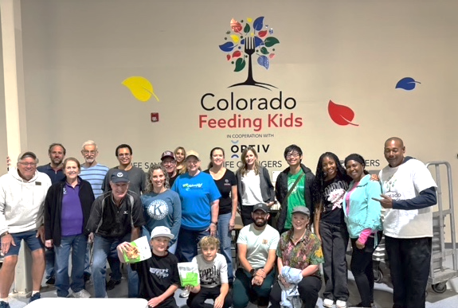
Thanks to volunteers Gail Coombs, Lizzie Coombs and Dave Rich.

Denver Children’s Home - Saturday Nov 1st Painting Event –
Guest artist is a local high school teacher. His father was a Kiwanian in Georgia.
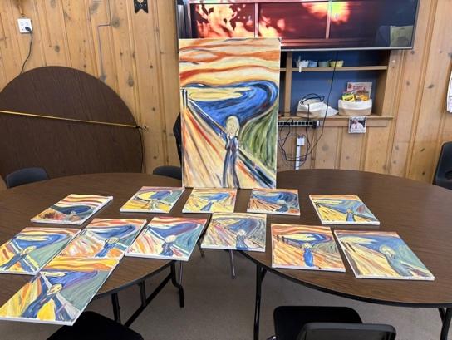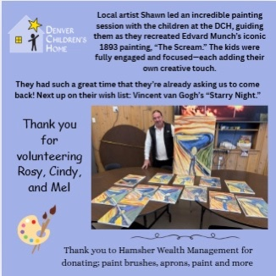

Upcoming Events and Volunteer Opportunities TBD

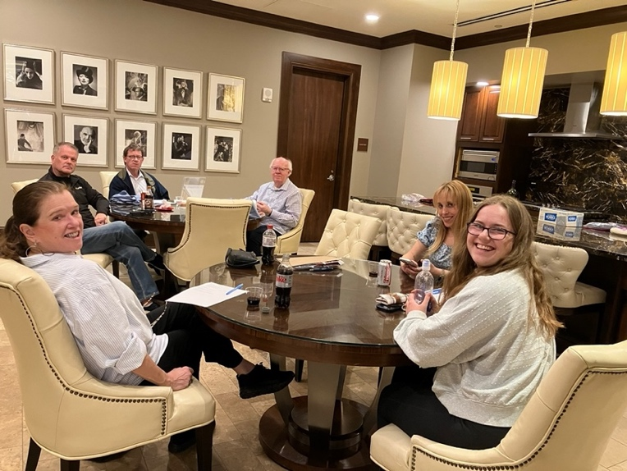

$47.31 Amount received from King Soopers Cards used in Community Rewards. Sign up if you haven’t already. See below.

If you have a King Scoopers Card - select Kiwanis Southeast Metro Denver Club Community Rewards recipient
How to do this:
Go to the Kings Scoopers app on your phone.
Click on the three red lines on the upper right corner.
Select Rewards.
Select Community Rewards.
Search for Kiwanis Southeast Metro Denver Club
Save it.
$80 accrued in 4th quarter 2023 -More people involved means more earnings for the club!

