Seeds and Leads
New Membership Promotion Form
(Jan – June 2022)

New Member Name _____________________________________________
E-mail _______________________________________________________
Sponsors Name __________________________________________________
E-mail _______________________________________________________
Club Name ______________________________________________________

Has the New Member been in Kiwanis before? Yes ________No ______
If yes, was it prior to 10-1-2020? Yes ________No ______

Date New Member joined _________________________________________________
Date New Member attended first club Meeting_________________________________
Date New Member attended first Club Service Project or Fundraiser Event __________

When New Member attends the first meeting and Club Service or Fundraiser Event, send this completed form to Bob Willey, membership chair at membership@newenglandkiwanis.org

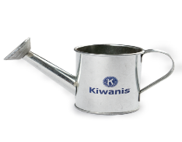
A Kiwanis logo Watering Pot will be sent to the new member in recognition of their “growing” Kiwanis involvement.

All Fully Completed and submitted Forms will be eligible for the New Member to receive a complimentary registration as well as overnight accommodations (with a maximum value of $500) to August District Convention August 18 – 21, 2022 at Radisson in Nashua, NH. Winner will be announced in July 2022.

