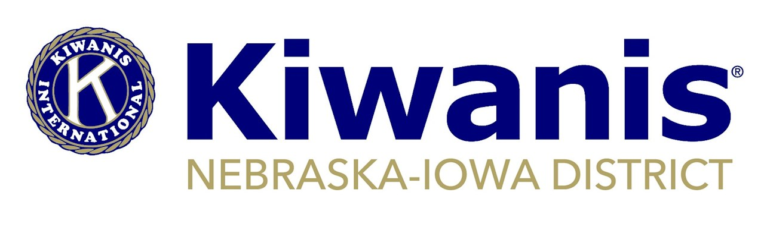

**Minutes**

**District Board Meeting**

**March 12, 2021 • Zoom**

**Welcome – Curt – 5:37 p.m.**

**Roll Call – Present In Bold**

Officers & Trustees: **Gov. Curt Reis; Gov. Elect Don Fritz; Vice Gov. Lynda Henningsen; Past Gov. Lenora Hanna; Dist. Admin. Lisa Brichacek; Dist. Treasurer Sue Griffith; Trustees: Reg. 1 Gary Muckel, Reg. 2 Barb O’Donnell, Reg. 3 Norma Beaver; Reg. 4 Gary Lindgren, Reg. 5 Andy Webb** (enter 5:43 p.m.) and **Reg. 6 Jim Dane** (exit 7:07 p.m.); Service Leadership Administrators: **Kathee Uhrmacher, K-Kids; Jim Dane, Builders Club; Tracey Scissors-Domgard, Key Club; Travis Grafe-Cline, Circle K; James Brewer, Aktion Club;** Others: **District Membership Chair Gary Wattnem; Kiwanis Children’s Fund Advocate/District Foundation President Jody Melcher; District Foundation Treasurer Lonnie Shumate**

1. **Reports**
   1. SLP administrators: Kathee Uhrmacher - most clubs are not meeting because of COVID; Jim Dane - there are 27 Builders clubs in District and 15 are active this school year; Tracey Scissors-Domgard - some Key Clubs are meeting, but no Kiwanians allowed in school, district Key Club board has been active and a Kiwanis club is being sought to sponsor a new Key Club in Waukee area; Travis Grafe-Cline - membership continues to grow and build on success of last year, Hastings College has a new club and several new clubs are being looked at in Iowa; James Brewer – 31 Aktion Clubs in the district, with 14 listed as COVID-A status.
   2. District administrator: Nothing additional to offer and written report submitted to board members prior to meeting.
2. **Approval of Board Minutes of Jan. 9, 2021**

*Motion by Dane, second by Fritz to approve minutes as presented. Motion carried unanimously.*

1. **District treasurer and finance committee reports** – Sue/Gary L.

Griffith reported the District’s 990 has been completed by the new firm hired to do financial compilation. The paperwork for direct deposit of payroll is being researched. The district applied for and received approval of Payroll Protection Program, which is available through the Federal stimulus package. This initially gives the District a $9,942 loan that is to be used for the purposes of payroll. With proper documentation and follow-up, this loan is forgivable. Financials for past months were not yet ready for review, but will be emailed following meeting.

Lindgren reported that the finance committee is now meeting quarterly.

1. **Foundation Report and Memorandum of Agreement Approval** – Jody/Curt/Lonnie

There was no formal report from the District Foundation. The Foundation board has approved an amended Memorandum of Agreement with the District. The new MOA has a few wording changes from the MOA that was approved by the District board in October. This agreement will be reviewed by committee on an annual basis.

*Motion by Dane, second by Lindgren to approve the amended Memorandum of Agreement between the Nebraska-Iowa District and the Nebraska-Iowa District Foundation and authorize Gov. Curt Reis to sign on behalf of the District. Motion carried unanimously.*

1. **LaRue Committee Recommendation** – Lynda

The committee made a recommendation to use the $12,744.42 from Past Gov. James LaRue’s estate over the next two to three years. The initial focus is on SLP projects, but the committee is planning to meet twice a year to assess District needs and make additional recommendations as necessary. For an initial plan, the committee recommended providing two $500 Key Club Scholarships in 2021 and two $500 Key Club Scholarships in 2022. The committee further recommends providing support to Circle K in the 2021-2022 year by subsidizing registrations to District Circle K conferences, which will hopefully encourage more members to attend. Future funding to Aktion Clubs in 2021-2022 to support Aktion Clubs regional conferences or specific activities for members is also being explored.

*Motion by Lindgren, second by Dane to accept the committee’s initial proposal and approve the expenditure of $1,000 in 2021 and $1,000 in 2022 to be used for Key Club Scholarships.*

1. **Kiwanis Children’s Fund Grant** – Jody/Curt

Melcher reported there was less money available this year from the KCF grant program. The District is expected to receive only $1,669.54 this year. Last year, over $11,000 was received and it was split to benefit Key Leader, Key Club Scholarships and the District’s Eliminate pledge. Discussion included the fact that Key Leader only happened virtually this year and the funds from the KCF grant were held over for use at the next Key Leader. The $1,000 allocation from the LaRue fund will take care of Key Club Scholarship needs this year.

*Motion by Hanna, second by O’Donnell to allocate the grant dollars received this year from the Children’s Fund rebate program to the District’s Eliminate pledge. Motion carried unanimously.*

1. **Membership Report and New Drive Initiative – Gary W.**

Past new member drives have been successful but the District’s net growth is already beginning to take a downward trend for the year. At the end of last month, membership was negative 18 since start of the year. The proposal is to have a membership initiative that starts in May and lasts through the end of the year. It focuses both on new members and current member retention and has two tiers, one for clubs with 30 members or more and one for clubs with 29 members or fewer. Winning clubs in each category will be determined as those clubs with the greatest percentage increase in membership per the KI monthly reports. In case of ties, the money for a certain place will be split evenly. The winning clubs will be given grant dollars to be used for service projects, community improvement and educational scholarships. Top prize in each tier is $1,000, with second place receiving $750 and third place getting $500. There is money in the budget under the growth line item to support the prizes.

*Motion by Webb, second by Lindgren to conduct a district membership contest from May 1 through Sept. 30 and to award grant dollars as proposed to the top three clubs in each category. Motion carried unanimously.*

1. **Charter Suspension Notices to Clubs** – Lisa

The District has been notified that 20 clubs were sent charter suspension (CS) notices in February by KI for balances due more than 90 days. District administrator is contacting these clubs. Some clubs paid when CS notices were received. A few clubs have reported billing discrepancies or other issues; these are being worked through with KI with the help of the District leadership.

1. **Prorated New Member Dues and other KI Updates** – Curt/Lisa

The new structure for new member dues will go into effect Oct. 1, 2021. There will no longer be “fees” for new members. New members will pay dues equal to member annual renewals, and these dues will be prorated 1/12th less each month as the year progresses. It is probable that the House of Delegates will need to pass a bylaw amendment at convention to change the wording for new member dues.

1. **Amplify and Scholarship Applications** – Don

March 15 is the deadline for scholarship applications. Eight applications have already been received.

1. **Electronic payments options** – Lisa

Exploration of the options is still on hold and will be done as time permits.

1. **Division restructuring committee update** – Don

No update at this time.

1. **Nomination Committee Recommendation for 2021-2022 Vice Governor** – Lenora

The nomination committee this year is Hanna (chair), Sue Waldren, Jan Burch, Chuck Beck and Paul Brenner. Dale Doudna of the Kiwanis Club of Johnston, Iowa was nominated and has accepted the nomination.

*Motion by Webb, second by Beaver to accept the nomination committee’s recommendation and support Dale Doudna as candidate for 2021-2022 vice governor.*

1. Virtual Midyear Awards and Signature Projects – Lenora

The virtual midyear award program was well received. There were more than 80 watching the live broadcast on Feb. 23 and now the video on You Tube has been viewed more than 200 times. With the possibility of not having Mid Year Conferences in the future, this might be the way to continue to do Mid Year Award programs.

1. **2021-2022 Division Leadership and Lt. Gov. Elect Training** – Don

More Lt. Govs. are still being sought for the 2021-2022 class. The training will be done virtually on June 5.

1. **March 13 District Leadership Development Conference** – Curt

Good participation is expected and a “camp” experience is ready for those attending.

1. **International Convention Update** – Curt

Plans for the convention and/or education conference are still changing as the pandemic requires. Watch the website and emails for details.

1. **District Convention – August 6-7, Sioux City, IA** – Lisa/Curt

The committee is continuing plans for an in-person convention. Regional meetings, House of Delegates, education breakouts and more are planned. A virtual link will be offered as well.

1. **Club Leadership Chat Update** – Lisa

The CLCs continue to draw participants and good comments from across the District. March’s CLC is focused on club secretaries. Two are planned for April, one for Key Club advisors and one for membership/club growth.

1. **Secretary of State Filings** – Curt/Gary L./Gary M.

An updated list of clubs still not in compliance was discussed. Clubs will continue to be contacted to get this addressed.

1. **Adjourn – 7:56 p.m.**

Next Meeting Friday, June 4, time to be announced.

*Submitted by Lisa Brichacek, District administrator*