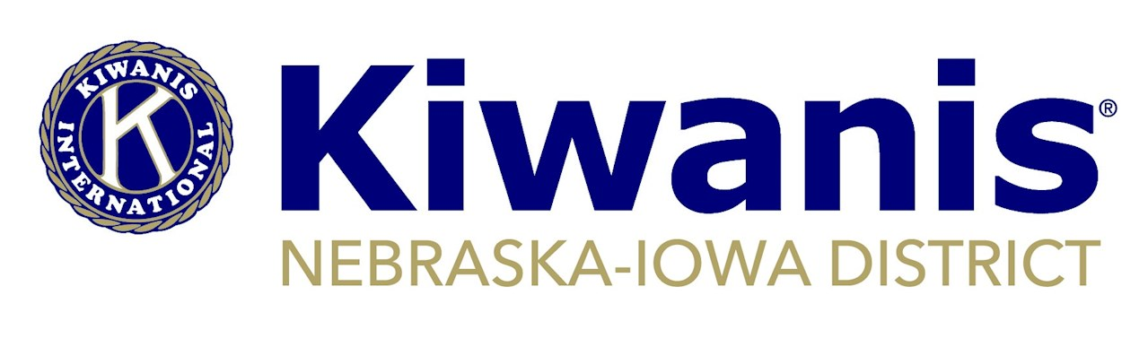

**MINUTES**

**Board of Trustee Meeting**

**January 9, 2021 – 9 a.m.**

**Virtual Zoom Meeting**

Welcome - Curt

**Roll Call**/Introduction and Sharing – All

**Present in Bold:** **Gov. Curt Reis; Gov. Elect Don Fritz; Vice Gov. Lynda Henningsen; Past Gov. Lenora Hanna; Dist. Admin. Lisa Brichacek; Dist. Treasurer Sue Griffith; Trustees: Reg. 1 Gary Muckel, Reg. 2 Barb O’Donnell, Reg. 3 Norma Beaver; Reg. 4 Gary Lindgren, Reg. 5 Andy Webb and Reg. 6 Jim Dane; KI Trustee Cathy Szymanski; District Membership Chair Gary Wattnem; District Financial Advisor Larry Ziska**

1. **Comments from Kiwanis International Trustee Cathy Szymanski**

Membership ideas, Amplify, staying connected with SLPs and upcoming activities were among the topics presented. During a brief question and answer, COVID waivers were also discussed. A condensed version is now available and will be emailed to disseminate to clubs.

1. **Approval of Minutes: Oct. 2-3, 2020, Oct. 24, 2020 and Nov. 7, 2020**

*Motion by Webb, second by Dane to approve the minutes of all three meetings as presented. Motion carried unanimously.*

1. **Treasurer’s Report** – Sue and Larry

Ziska reported expenses for the first quarter continued to be below budget, due to decreased activity related to pandemic. He recommended taking a look at transferring money from the District’s checking into the Money Market account in order to get interest. The Finance Committee will start meeting regularly during the year for a more timely review of finances. Revenue from club dues was still trickling in. The transition for Sue to become the district treasurer is progressing. The Board again thanked Ziska for his many years as treasurer and his willingness to serve as financial advisor this year.

*Motion by Lindgren, second by Fritz to look at moving money from the District’s checking to the money market. Motion carried unanimously.*

1. **Lincoln Fallbrook Club’s request for name change** – Curt/Lisa

The club has made this request and is aware of what needs to be done with the Secretary of State and IRS. The required process is for the club to have district approval before the request is presented to Kiwanis International.

*Motion by Fritz, second by Lenora to approve of name change for Kiwanis Club of Lincoln, Nebraska – Fallbrook (K18753) to Kiwanis Club of Northwest Lincoln and to authorize District Administrator Lisa Brichacek to sign the necessary form and forward to KI.*

1. **District Leadership Development Conference** – Curt

This will be held March 13, with Board, Lt. Governors, district chairs and SLP chairs invited. Due to ongoing pandemic related concerns, this will be virtual only event. The March 12 board meeting will also be virtual.

1. **Discussion on electronic receipts** – Curt/Lisa

Brichacek asked that this discussion be put on hold for right now. KI is conducting a survey of what districts are using for e-payments and this could help determine what is the best tool.

1. **Waiver of new member add** – Curt

There has been no indication that another waiver will be initiated by KI.

1. **Division w/o Lt. Gov**.

Regional trustees and lieutenant governors in neighboring divisions should help with communication and other support needs in these divisions. There needs to be a team approach to finding leaders for these divisions for the coming year.

1. **Division restructuring**

This is needed, but it is probably more prudent to wait until COVID-related club closures can be better assessed. However, now is the time to assemble a committee and start the strategy and background process. Fritz, Ziska, Henningsen and Webb agreed to serve on a committee and to contact a few past governors to assist. Fritz volunteered to be committee chair.

1. **Membership & monthly adds and deletes report** – Gary Wattnem

The new member drive in October and November was again a success. Forty-two clubs added 77 members. Since Oct. 1, there have been 137 new members. The four winners were drawn for the prizes to sponsors who brought in new members. Another membership drive is planned for later in the year.

1. **ICON – June 23-26 in Salt Lake City** – Curt

The District will be headquartered at Holiday Inn Express, which is near the convention center. Other plans for convention are still being developed. The KI board will be meeting to discuss the convention as it relates to the pandemic. Registration is not open yet, but those wishing to get information once it does can go here: https://www.kiwanis.org/convention/2021-convention-holding-page

1. **Update on DCON – August 6-7, 2021** – Lisa/Curt

Stoney Creek Hotel and Convention Center will meet the needs of an in-person/virtual convention. The contract with the hotel is still pending. A committee has yet to meet.

1. **District SLP and background check policy**

A monthly report is now being sent to District Youth Protection Manager Linda Placzek with the names of members whose background status is about to expire. She has been asked to check those lists for current SLP advisors. Brichacek is contacting board members, lieutenant governors and SLP admins should they appear on that list.

1. **District Aktion Club dues** – Lisa

Invoices for district dues have been sent to the seven clubs that are currently reported as meeting. Working with Aktion Club Administrator Jim Brewer, it was determined that there was a handful of clubs that are not meeting but had not reported that to KI. Those clubs were reported and are now listed as A-COVID.

1. **2021-2021 Vice Governor Nomination** – Lenora

A candidate has been identified and has accepted the nomination. However, a family situation has arisen in recent days that has the possibility to impact that acceptance. The board deemed it best to wait to take action on a nomination. Beaver requested that the name of the candidate be withheld from the board minutes.

1. **Mid Year Awards** – Lenora

A live virtual presentation is planned. This will either be done on Facebook or You Tube. The board set 7 p.m. on Tuesday, Feb. 23 at the event date.

1. **Signature Project** – Lenora

Signature project can be submitted Jan. 10 to 31 through a form established by KI. The awards committee will select the two clubs that will advance from the District to international competition and they will be announced during Mid Year Awards.

1. **CKI DCON**

The CKI district convention will be held virtually March 19-20.

1. **Key Club DCON**

The tentative plans are to hold this convention April 8-11 at the Mid America Center in Council Bluffs.

1. **Lt. Governor Training update** – Don

The first Saturday in June is being tentatively scheduled for lieutenant governor elect training. The current plan to hold this as an in-person and virtual event.

1. **Policy and procedures updat**e – Curt

District Policy and Procedure Chair Jan Burch has indicated she will be working on updates. There was no timeline established.

1. **Foundation Report** – Curt

Lonnie Shumate will be the Foundation’s representative to the District board. The Foundation board will be meeting later this month.

1. **Foundation MOA**

The memorandum of agreement approved by the District Board in October has still not been approved by the Foundation board. Foundation board members have asked for a few wording changes and this is expected to be on the Foundation’s January agenda.

1. **Strategic Plan** – Don

The strategic plan update developed over the past several months had been sent in advance to board members for review. There were no questions. This plan targets initiatives through 2022.

*Motion by Lindgren, second by Webb, to approve the updated strategic plan and place it on the District’s website. Motion carried unanimously.*

1. **Amplify**

The fee per participant is $200 and registration opens Feb. 15. For every six registered, the District will receive a $200 rebate. It was agreed that the District should help promote and support this leadership program as it fits in with the strategic plan. There are leadership and training dollars in the budget.

*Motion by Fritz, second by Lindgren, for the District to sponsor six Amplify scholarships. Motion carried unanimously.*

1. **LaRue & Armstrong monies, designations** – Lisa/Curt

A committee of Henningsen, Lindgren and Dane was appointed to determine the best use of the $12,744.42 from the Past Gov. James LaRue estate. Henningsen volunteered to serve as chair of the committee.

The Council Bluffs Downtown Club donated $100 in honor of Lt. Gov. Elaine Armstrong. In appreciation for her leadership, it was determined that money would fit in with the Amplify program.

*Motion by O’Donnell, second by Dane to put the $100 honorarium for Armstrong toward the Amplify scholarships. Motion carried unanimously.*

1. **Trustee Elections / Regional meetings** – Lisa

Terms will expire at the end of the current Kiwanis year for Reg. 1 and Reg. 4 trustees. The procedure has to been to elect during Mid Year Conference but there will not be a conference this year. District Convention is an option for holding meetings and elections. There were no objections voiced to holding said meetings and elections in August.

1. **Secretary of State Filings** – Curt

The requirements were reviewed and work will continue to get all clubs in compliance.

1. **Finance Committee Frequency** – Gary

Motion by Henningsen, second by Beaver to have the finance committee meet on a quarterly basis. Motion carried unanimously.

1. **Administrators Report** – Lisa

Received as presented in advance by written report.

1. **Other**

Henningsen reported that Kiwanis International will have representatives at the District’s Virtual Key Leader on Jan. 23.

1. Adjourn at 12:15 p.m.

*Submitted by District Administrator Lisa Brichacek*