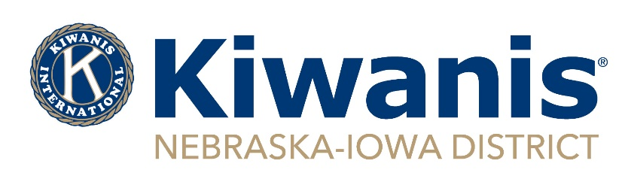
District Board Special Meeting Minutes
Feb. 28, 2022, Via Zoom – 7 p.m.

Establishment of Meeting: On Feb. 24, under the provisions of Nebraska-Iowa District of Kiwanis International By-Laws, Article IV, Section 3., Gov. Don Fritz called a special meeting of the District Board for Monday, Feb. 28 at 7 p.m. via Zoom and all board members were notified.

Roll Call – Quorum Established
Present: Gov. Don Fritz; Gov. Elect Lynda Henningsen; Vice Gov. Dale Doudna; Immediate Past Gov. Curt Reis; Administrator Lisa Brichacek; R1 Trustee John Boltz; R2 Trustee Barb O’Donnell; R5 Trustee Andy Webb. R6 Trustee Jim Dane. Absent: Treasurer Larry Ziska; R3 Trustee Norma Beaver; R4 Trustee Gary Lindgren.

Approval of the Agenda
Henningsen requested the addition of two agenda items: 1. K-Family Night sponsored by District Key Club; 2) Treats sponsorship for Circle K and Key Club conventions.
Motion by Webb, second by Reis to approve the agenda as amended. Motion carried unanimously.

Kiwanis Children’s Fund Grant
The district has received $7,640.39 this year as its rebate grant. The allocation of this money needs to be sent to KCF by March 1. The executive committee offered several options, which were sent to all board members in advance for thought and initial discussion. Allocating funds to Camp OK had been one of the original ideas. But after a chat with District Foundation President Jody Melcher that has been taken off the table as Camp OK is a Foundation activity and it is able to fund it. Additional funds for Key Club scholarships and starting a Circle K Scholarship still had favor, as long as it was made known this might be a one year only allocation.
Motion by Boltz, second by Webb that distribution of this year’s Kiwanis Children’s Fund Grant shall be $3,000 to Key Leader; $2,000 to Circle K Scholarships (to be split into four scholarships); $1,000 to Key Club Scholarships (to be an additional two scholarships to the previously approved LaRue fund scholarships); and $1,640,39 toward the Nebraska-Iowa District’s unfulfilled pledge for maternal and neonatal tetanus elimination. Motion carried unanimously.

Policy and Procedures Review
Fritz proposed that a meeting be scheduled in March for the purpose of reviewing the entire Policy and Procedure document and that Jan Burch, who recently completed the revision to that document, also be invited to attend. The meeting will be held at 7 p.m. on March 24 via Zoom. A PDF of the proposed Policy and Procedures revisions is still accessible in the board’s Jan. 22 DropBox folder. The document does show the current Policy and Procedures as well as the revisions.

K-Family Night
The Nebraska-Iowa Key Club District Board is sponsoring a K-Family night on Saturday, March 5. Registrations numbers by Kiwanians has so far been low and board members are encouraged to join. An email with registration links will be sent to all Kiwanians in the district later this week.

Sponsorship for Circle K and Key Club conventions
Circle K and Key Club both have their respective district conventions in the next few months. To show support, it was proposed that the District sponsor a treat or dessert table at each of the conventions. District Treasurer Ziska had been consulted prior to the meeting and reported that there would be money in the budget to do so. Expected cost is $200 to $300 per convention. Henningsen agreed to organize the activity.
Motion by Dane, second by O’Donnell to sponsor treats or desserts at each district convention of Circle K and Key Club, at a total cost for both not to exceed $600. Motion carried unanimously.

Meeting Adjourned – 7:37 p.m.

Submitted by District Administrator Lisa Brichacek

