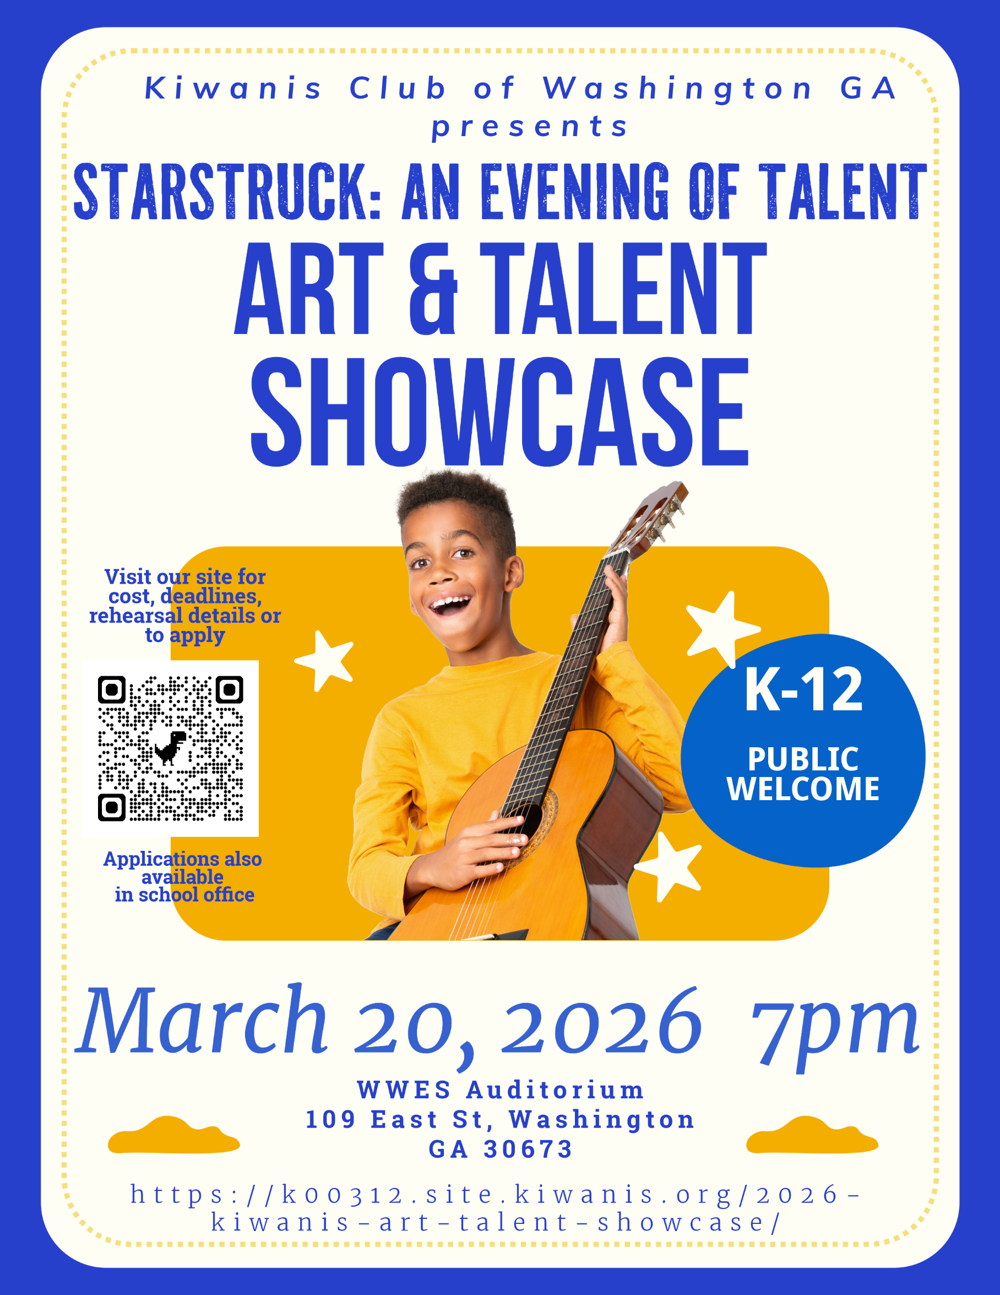



Sponsorship Levels

Advertising Benefits
Starstruck: An Evening of Talent

Please select the level of sponsorship that best suits your organization:

- Platinum Sponsor – $1,000+
Includes recognition on event banners, promotional materials, social media platforms, website, and public acknowledgments at events.

- Gold Sponsor – $500
Includes recognition on promotional materials, social media platforms, website, and public acknowledgments at events.

- Silver Sponsor – $250
Includes recognition on promotional materials.

- Bronze Sponsor – $20 - $100
Includes a mention in our event program.

Sponsor Information
(Please print clearly)
- Business/Organization Name: ___________________________
- Contact Person: ___________________________
- Address: ___________________________
- City, State, ZIP: ___________________________
- Phone Number: ___________________________
- Email Address: ___________________________

Payment Information
- Total Sponsorship Amount: $__________
- Payment Method:
☐ Check (Payable to Kiwanis Club of Washington, GA)
☐ Cash

Please return this form along with your payment to:
Kiwanis Club
PO BOX 113
Washington, GA 30673

*If you would like your logo included in the Art & Talent Show program, please email it to: wwkiwanis@gmail.com

About the Kiwanis Club of Washington, GA

Welcome to the Kiwanis Club of Washington, GA
The Kiwanis Club of Washington was the 312th club organized under Kiwanis International on September 29, 1920 — and we just celebrated our 105th birthday!
We are an eclectic mix of ages, genders, occupations, backgrounds, and interests. What unites us is our passion for making our community and the world a better place for children so they can thrive. We are devoted to serving the children in our local community and children across the country and worldwide through unique and innovative service projects and fundraising initiatives.

What We Do
The Kiwanis Club of Washington, Georgia, is deeply committed to positively impacting our community through various service projects and donations. From supporting local schools and youth programs, the club works tirelessly to improve the lives of those in Washington and surrounding areas.
To stay up to date on all our upcoming events, including volunteer opportunities, fundraisers, and other initiatives, we encourage you to follow us on Facebook: Kiwanis Club of Washington Georgia. By liking our page, you’ll be the first to hear about ways you can get involved and help make a difference in our community. Join us as we continue to support the people and causes that matter most!

Our Recent Projects
- Veterans Appreciation Event
Hosted a community event for 26 veterans and their families, featuring heartfelt letters from students and inspiring words by retired Navy Captain Bill DeGolian.
- Dictionary Project
Donated 100 Merriam-Webster Student Dictionaries to third graders at Washington Wilkes Primary School.
- College Scholarship
Awarded a $1,000 scholarship to WWCHS Senior Jordan Dawson for academic excellence and community service.
- Art & Talent Showcase
Organized a community fundraiser celebrating local talent while supporting ongoing Kiwanis projects.
- Washington Georgia Tour of Homes
Held our largest annual fundraiser, showcasing local homes' historical charm and architectural beauty.
- Sponsorships & Donations
Supported youth-focused programs, including:
  - Washington Wilkes FFA
  - Wilkes County Kids
  - Wilkes County 4H
  - Washington Wilkes Little League
  - WWCHS Sports Teams

Acknowledgment
Thank you for supporting the Kiwanis Club of Washington, GA. Your generosity helps us make a difference in the lives of children and the well-being of our community.
COME JOIN US!
We meet at Country Financial in Washington, GA EVERY Tuesday at 1 PM.

