Carrollton Kiwanis
Newsletter
July 11, 2022 | Serving the Children of the World

Officers  President: Bill Bollinger  Pres.-Elect: Jeff Adams  Vice President: Tracey Wozny  Secretary: Ron Schuler  Adm. Treasurer: Robert Pavlu  Act. Treasurer: Norm Bliss  Past Pres.: Jay Wilson  Lt. Gov. Greg Atkins, Smithville  Region 1 Trustee, Bill Dooley  Board of Directors  Andy Kelb  Jim Gibson  Mary Jane Phillips  Jim Bowen  Earl Austin  David Martin  Facebook  @carrolltonmokiwanisclub  Websites  Kiwanis.org  Moarkkiwanis.org  div3kiwanismoark.weebly.com  July Birthdays  Stacy Adams, 3  Jeri Burger, 3  Leann Polen, 8  Danny DeWitt, 12  Michael Schubach, 23  Jim Gibson, 25  Jim Paul, 31  Monthly Youth Meetings  Key Club  1st & 2nd Friday of month, 7:30 AM  Builders Club  2nd Wednesday of month, 3:05 PM  Terrific Kids Assembly  Awards given each month  Publications Editor  Ron Schuler | The Carrollton Kiwanis Club met at noon, Monday, July 11, int the BTC Bank basement with fourteen members and two guests, Chloe Lock and Corina Thorne, present. Norm Bliss and Jim Gibson got the meeting started with the Pledge of Allegience and invocation, respectively. The luncheon menu included beef stew over mashed potatoes, green beans, mixed fruit, rolls, and cherry cheesecake for dessert.  Past president Jay Wilson presided over the meeting in Bill Bollinger’s absence. His first order of business was to report a successful flag service on July 4th. The following members set flags around the community on that day: Jim Gibson, Stacy Adams, Norm Bliss, Bill Bollinger, Jim Bowen, Earl Austin, Earlene and David Martin, and Andy Kelb.  Member Loralee Sweeney invited the club to hold their meeting at her house at noon on Monday, August 8. The club accepted and looks forward to the change of venue.  Jay Wilson continued by reading two thank you notes from Kiwanis scholarship winners, Bruce Grider and Chloe Lock. We thank them for their appreciation and wish them a successful college experience.  Norm Bliss briefly discussed some flag service business as well as offering to the members trash can lids that were left over from the repair and repainting of the Kiwanis trash receptacles. Again, many thanks to the committee for their efforts on this project.  Earlene Martin reminded the club that the football concession stand service is right around the corner. Friday, August 26, is Carrollton High School’s first home game, and volunteers from our club are needed to work the concession stand for the five home games and Band Day. Future games are on September 2, 16 (Homecoming), 23, and October 7. Band Day is September 24.  Our program featured Corina Thorne, Director of the Carrollton Library. Corina began with a history of the library, which began in the 1930’s, as well as mentioning several programs the library offers, such as, outreach to local senior buildings, story time for children, summer reading programs, online resources, and many others. Their misson “is to be a hub of information, education, and recreation for the community.” We thank Ms. Thorne for her very informative presentation.  Our next meeting will be on Monday, July 25, at 6:30 PM. A board meeting will follow the regular meeting. Meanwhile, remain safe and have a great week!  Future Programs, 2022  Jul 25 – 6:30 PM, Regular/Board Meeting  Aug 8 – Noon, Regular Meeting at the home of John and Loralee Sweeney  Aug 22 – 6:00 PM, Regular//Board Meeting  Sep 12 – Noon, Golf Tournament Day, Eat at Carrollton Country Club  Final Thought  You cannot escape the responsibility of tomorrow by evading it today.  Abraham Lincoln  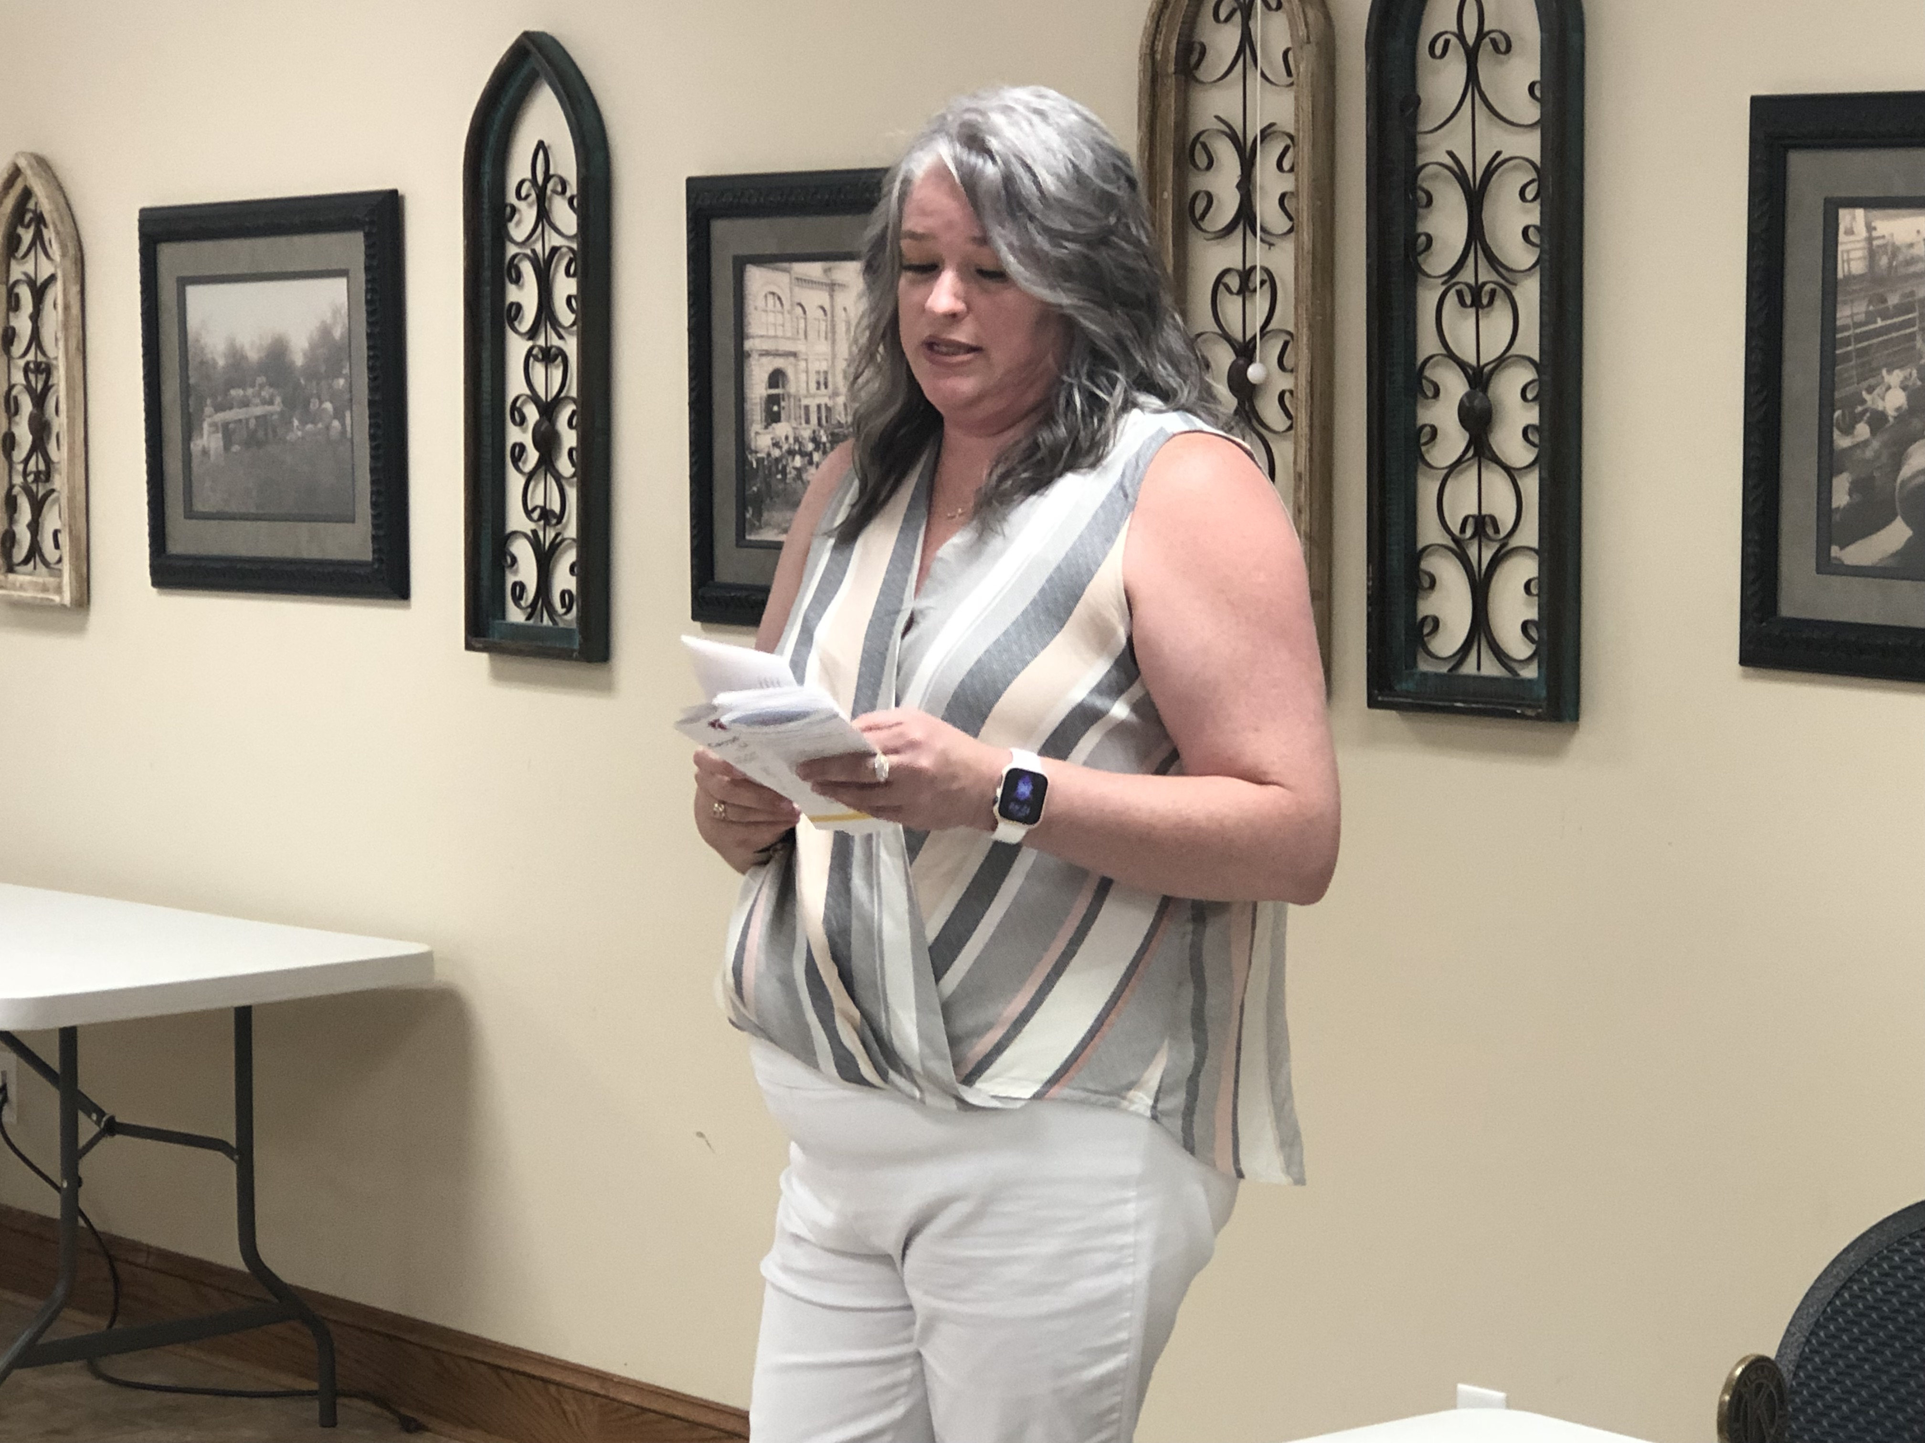  Corina Thorne, Carrollton Library Director  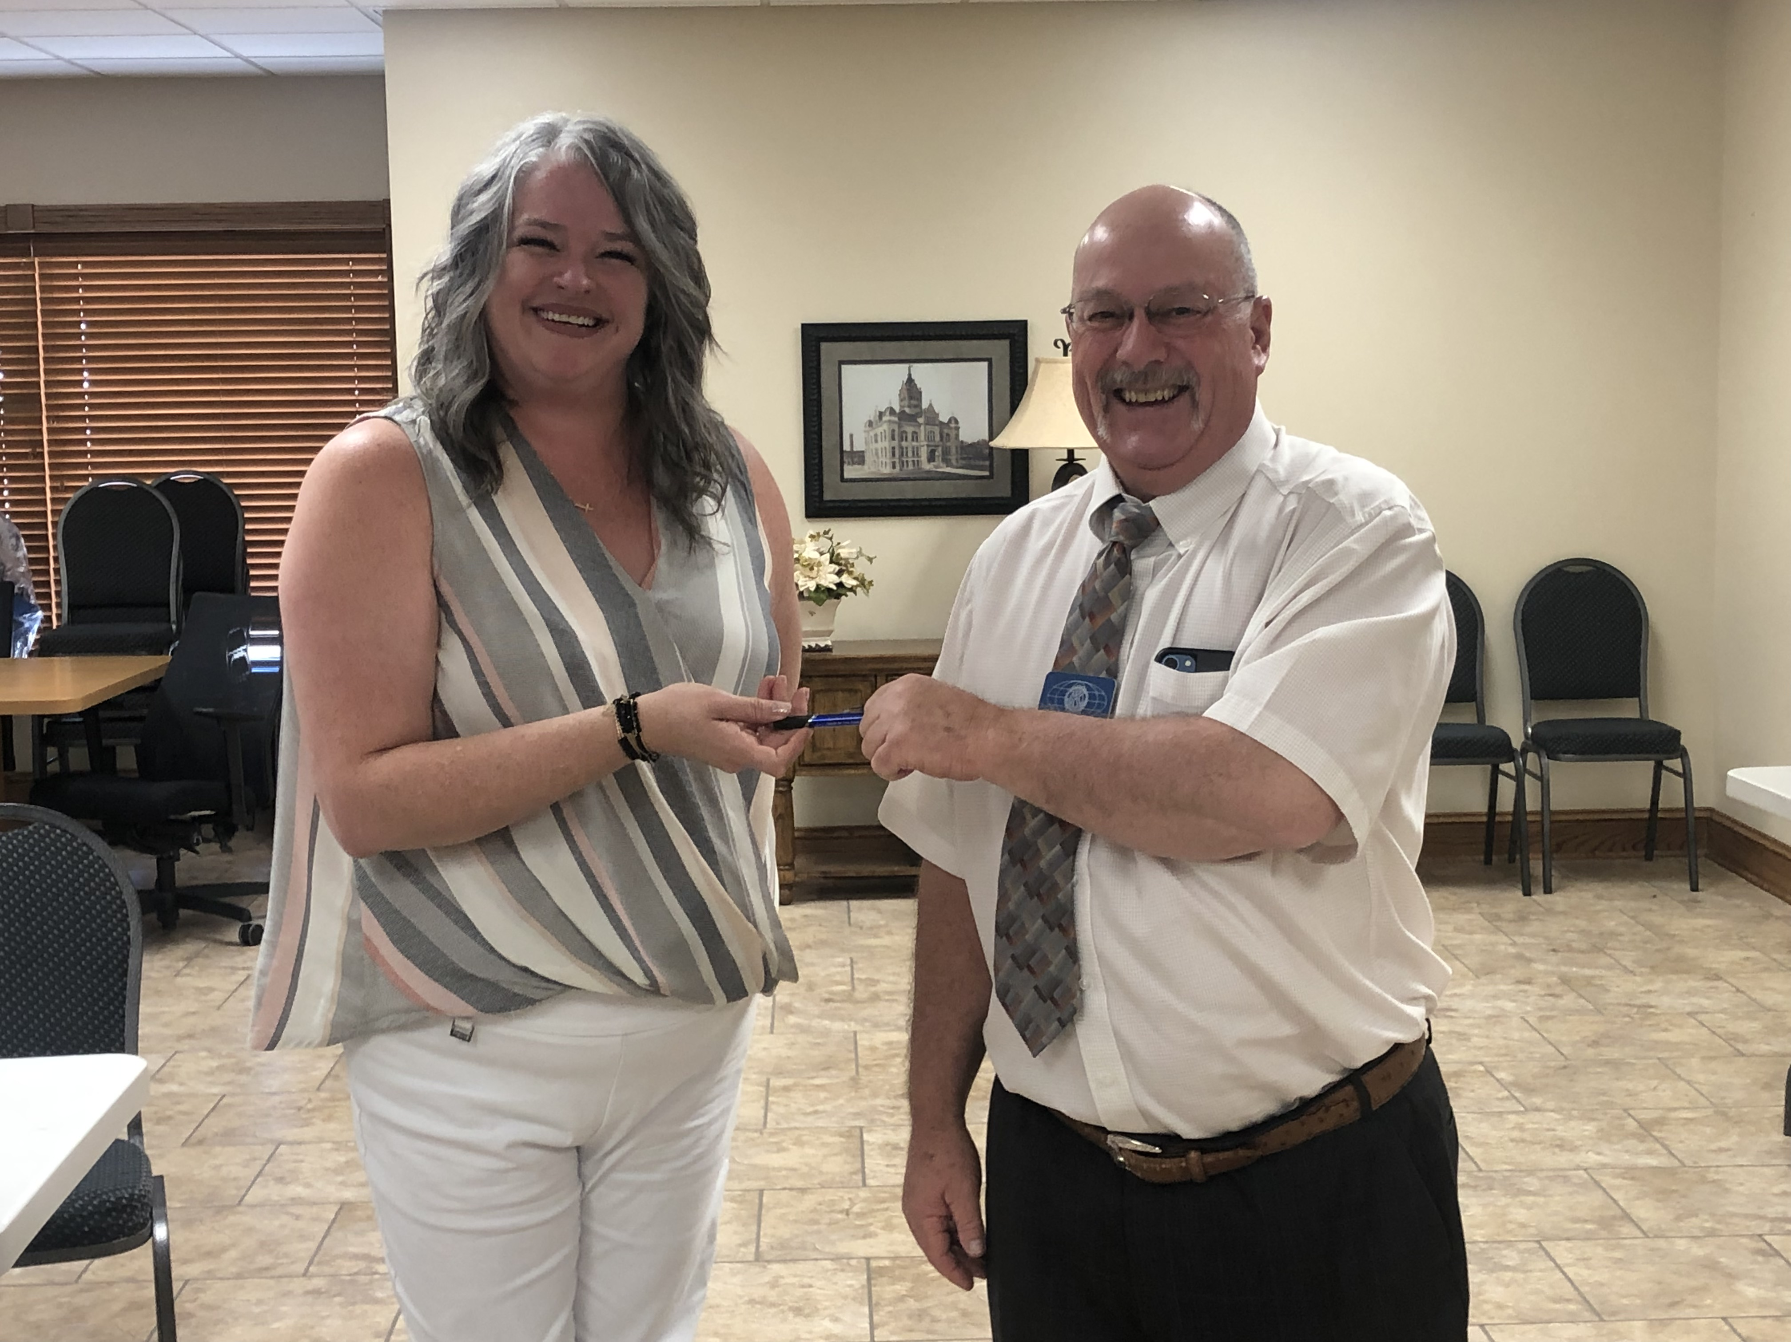  Corina Thorne & Jay Wilson

