Carrollton Kiwanis
Newsletter
May 8, 2o23 | Serving the Children of the World

Officers  President: Jeff Adams  Pres.-Elect: Tracey Wozny  Vice President: Jim Bowen  Secretary: Ron Schuler  Adm. Treasurer: Tarah Hilbrenner  Act. Treasurer: Norm Bliss  Past Pres: Bill Bollinger  Lt. Gov. Greg Atkins, Smithville  Region 1 Trustee, Bill Dooley  Board of Directors  Andy Kelb  Jim Gibson  Mary Jane Phillips  Ann Landwehr  Earl Austin  David Martin  Facebook  @carrolltonmokiwanisclub  Websites  Kiwanis.org  Moarkkiwanis.org  div3kiwanismoark.weebly.com  May Birthdays  Tarah Hillbrenner, 18  Kathy Lock, 3  Jason Martin, 20  Wayne West, 12  Tracey Wozny, 31  Monthly Youth Meetings  Key Club  1st & 2nd Friday of month, 11:52 AM  Builders Club  2nd Wednesday of month, 3:05 PM  Terrific Kids Assembly  Awards given each month  Publications Editor  Ron Schuler | The Carrollton Kiwanis Club met at noon on Monday, May 8, 2023, at the BTC Bank with twelve members and eight guests, present. President Jeff Adams called the meeting to order followed by the Pledge of Allegiance and invocation led by Bill Bollinger and Jeff Adams, respectively. Earlene Martin’s menu included spaghetti and sauce, buttered corn, tossed salad, hot rolls, and a brownie with vanilla ice cream Sunday.  Our guests were in two groups, an interclub from Liberty and our scholarship recipients. The Kiwanis members from Liberty were Jim Major and Patty Underwood. Jim spoke briefly about his commitment to Kiwanis, to which he hopes to be selected as our Region 1 Trustee for next year. A Trustee oversees several clubs in the Northwestern part of Missouri. Carrollton member, Jim Gibson, is familiar with that position, as he served as Trustee for five years. We appreciate Jim and Patty’s visit.  The highlight of our meeting was the opportunity to recognize and honor this year’s Carrollton Kiwanis Scholarship recipients. Each of the five seniors told the membership who their parents were, where they were going to college, and what they were planning to major in. The recipients of the $1,000 Kiwanis scholarships were Breanna Peel (parents Kristy & Chad Peel), Ruby Schmidt (Robert & Nancy Schmidt), Korbyn Broyles (Michael & Amber Broyles), Kaitlyn O’Dell (Patrick & Billie O’Dell), and Savannah Reinke (David & Michele Reinke). Our Kiwanis Club is grateful for the opportunity to help these students further their education and aspirations.  Flags were set out on Monday, May 8, Truman’s Birthday. The following members put flags around town in recognition of Missouri’s only US President: Jeff & Stacy Adams, Jim Bowen, Jim Gibson, Norm Bliss, David & Earlene Martin, Fred Phillips, Jarrod Crockett, Andy Kelb, and Ron Schuler.  The Terrific Kids End-of-the-Year celebration will be held on Tuesday and Wednesday, May 9 and 10, beginning at 1:30 pm to 2:40 pm at the Carrollton Elementary School. Kiwanis members are encouraged to help the teachers with the student activities.  A tour of the C4 facility has been arranged for Tuesday, May 9, at 10:00 am. All Kiwanians are invited to attend the facility. This invitation was given after Brandon Green’s presentation on their operation at our meeting on March 13.  Mother’s Day Baby Shower will take place on Saturday, May 13, from 9:00 am to 5:00 pm, at Mulch’s Country Mart. Donations of any baby products will be given to the Missouri Valley Human Resource Community Action Agency for distribution.  Our next meeting will be in the evening at 6:30 pm, on Monday, May 22, at the BTC Bank. A Board meeting will follow the regular meeting Stay safe and have a great week.  Future Programs, 2023  May 22 – 6:30 pm, Regular/Board Meeting  Jun 12 – Noon, Regular Meeting  Jun 26 – 6:30 pm, Regular/Board Meeting  Future Activities  May 9 – Terrific Kids End-of-Year Celebration, K-2, 1:30-2:40 pm  May 10 – Terrific Kids End-of-Year Celebration, 3-4, 1:30-2:40 pm  Final Thought  Sir, my concern is not whether God is on our side; my greatest concern is to be on God’s side, for God is always right. Abraham Lincoln  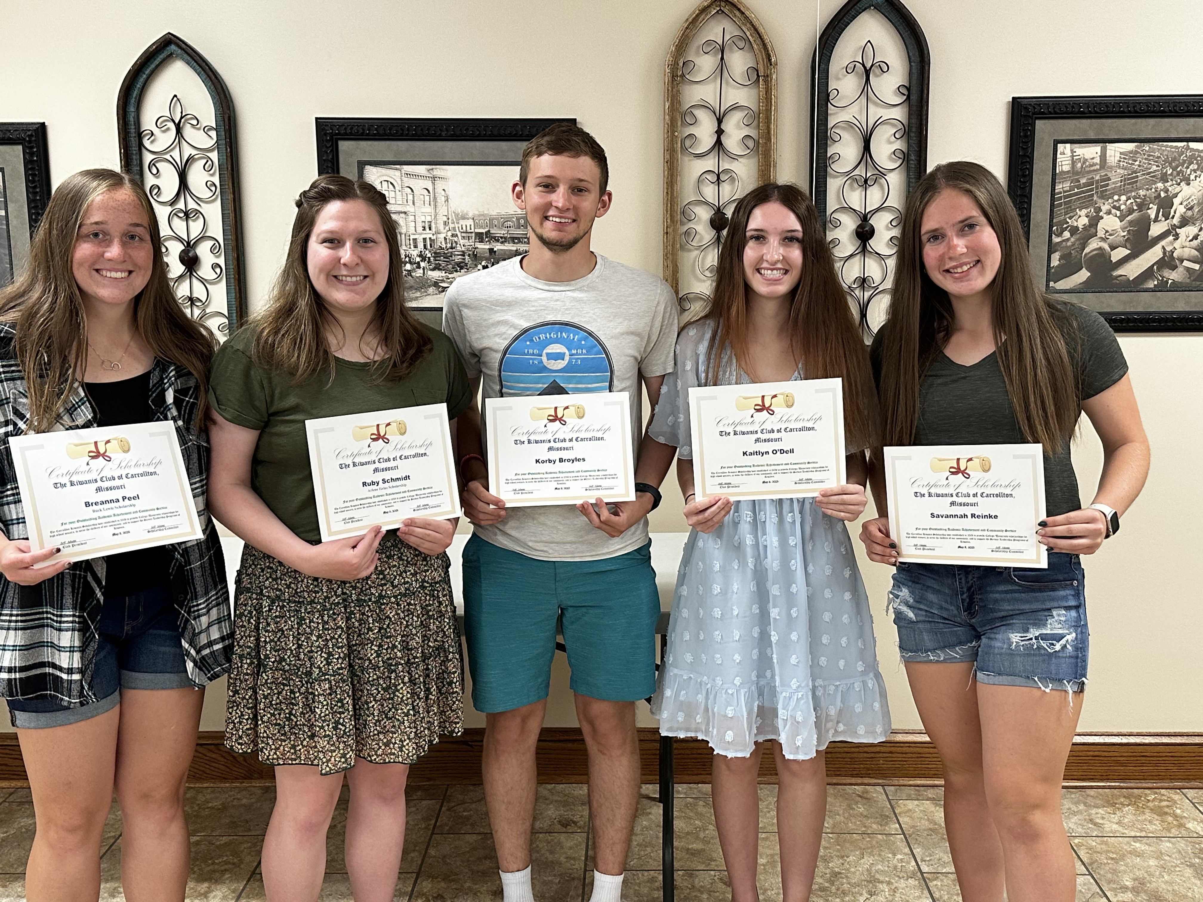  Breanna Peel, Ruby Schmidt, Korby Broyles,  Kaitlyn O’Dell, & Savannah Reinke

