 | Carrollton Kiwanis  Newsletter
August 28, 2o23 | Serving the Children of the World

Officers  President: Jeff Adams  Pres.-Elect: Tracey Wozny  Vice President: Jim Bowen  Secretary: Ron Schuler  Adm. Treasurer: Tarah Hilbrenner  Act. Treasurer: Norm Bliss  Past Pres: Bill Bollinger  Lt. Gov. Greg Atkins, Smithville  Region 1 Trustee, Bill Dooley  Board of Directors  Andy Kelb  Jim Gibson  Mary Jane Phillips  Ann Landwehr  Earl Austin  David Martin  Facebook  @carrolltonmokiwanisclub  Websites  Kiwanis.org  Moarkkiwanis.org  div3kiwanismoark.weebly.com  September Birthdays  Randall Barry, 11  Monthly Youth Meetings  Key Club  1st & 2nd Friday of month, 11:52 AM  Builders Club  2nd Wednesday of month, 3:05 PM  Terrific Kids Assembly  Awards given each month  Publications Editor  Ron Schuler | The Carrollton Kiwanis Club met on Monday, August 28, 2023, at 6:30 PM, with thirteen members and three guests, Lacey Waters, Christy Staton, and Mandy Shaw, present. The Pledge of Allegiance and Invocation were led by Jay Wilson and Bill Bolinger, respectively. There was no meal at this meeting, and Past President Bill Bollinger presided in President Jeff Adams’ absence.  Our program coordinator, Jim Bowen, introduced three directors from the Missouri Valley Resource Action Agency in Carrollton: Lacey Waters - Family Improvement Director, Mandy Shaw - Family Services Director, and Christy Staton - Community Outreach Specialist. Each director explained what services they could provide to lower- income families in several of the counties on this side of the State. The club members were very interested and asked several questions. Our town is very lucky to have such a wide variety of services available to those in need. Thank you, Jim, for arranging their presentation.  Bill Bollinger reminded the club that the Golf Tournament has been set for September 11, and will require several workers to prepare the clubhouse the day before and also during the all-day tournament. There is still room for more players, so encourage your golf friends to participate in this event. Talk to Jim Gibson, Jim Bowen, or Bill for details. Bill also reminded the club that members can sign up now for working the concession stand on Band Day as well as the four home football games. And, finally, there are three flag service days in the next two months. September and October are busy months for us!  Officer Installation Night is on Monday, October 23, at 6:30 PM. This is a special spouse’s night with Kiwanis Region 1 Trustee Jim Major, and Division 3 Lieutenant Governor Gary Goebel, attending. Please plan to join us.  A Board meeting followed the regular meeting with everyone attending. On the agenda was a discussion about filling three officer positions. As luck would have it, three volunteers offered their services. They were Jay Wilson - activity treasurer, Ann Landwehr – assistant secretary, and Bill Bollinger – president-elect. Other subjects discussed included a sign-up sheet for Band Day, appreciation items for guest speakers, and an update on play equipment in the Tot-Lot.  Volunteers are needed for flag service on September 4, Labor Day. Our next meeting falls on September 11, Golf Tournament Day, which means we will not have a meeting, but we are invited to have lunch at the Country Club, your attendance will be counted. Stay safe and have a great week!  Future Programs, 2023  Sep 11 – Noon, Regular Meeting  Sep 25 – 6:30 PM, Regular/Board Meeting  Oct 9 – Noon, Regular Meeting  Oct 23 – 6:30 PM, Officer Installation Night  Future Activities  Sep 4 – Labor Day, Flag Service  Sep 8 – Home Football Game, Concession Stand  Sep 11 – Patriot Day, Flag Service  Sep 23 – Band Day, Concession Stand  Sep 29 – Home Football Game, Concession Stand  Oct 9 – Columbus Day, Flag Service  Oct 13 – Home Football Game, Concession Stand  Oct 20 – Home Football Game, Concession Stand  Final Thought  Life is really simple, but we insist on making it complicated. Confucius  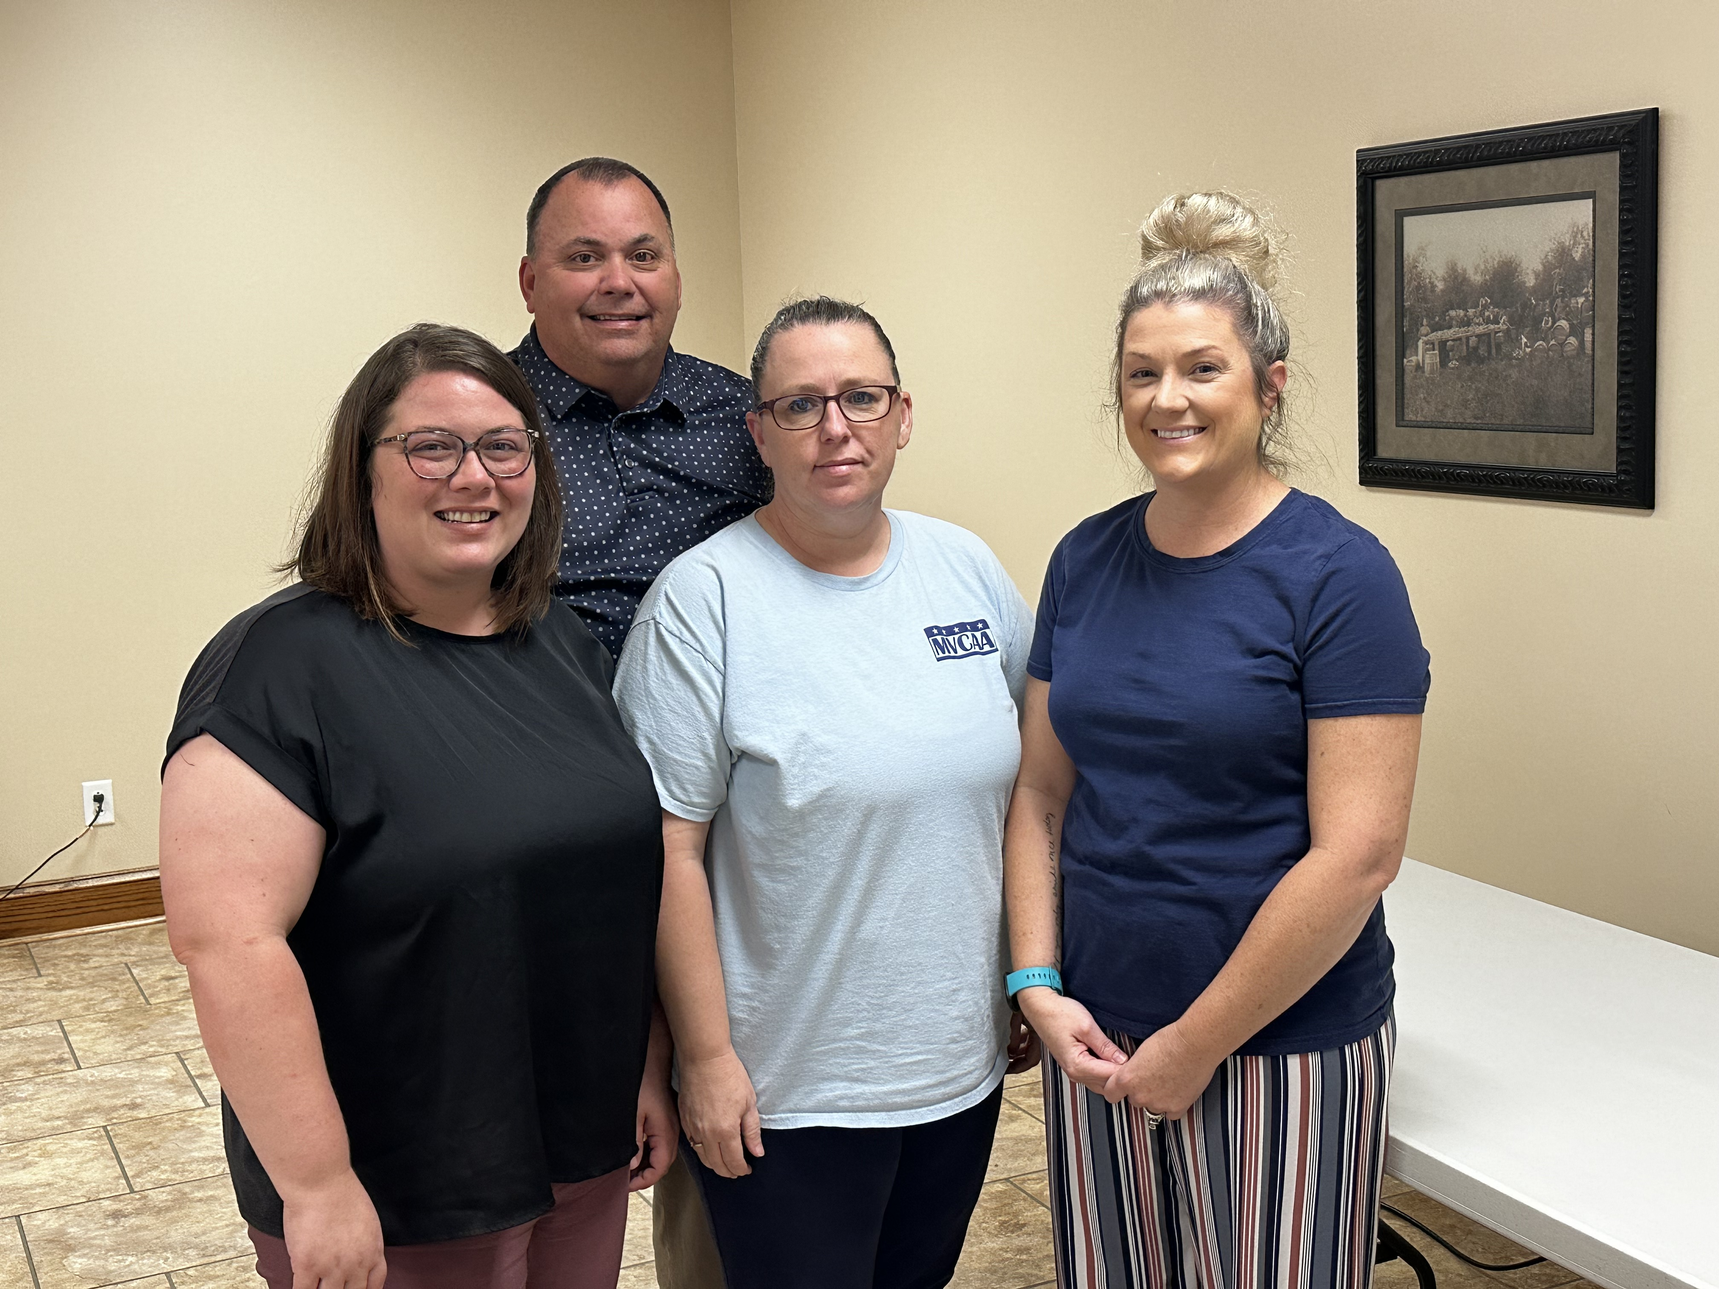  Lacey Waters, Christy Staton, Mandy Shaw w/Past-President Bill Bollinger

