Kiwanis·
MISSOURI-ARKANSAS DISTRICT

EARL COLLINS FOUNDATION

CLUB PRESIDENT: GRADING FORMS, INSTRUCTIONS & TIMELINE 2023-2024 SCHOLARSHIP APPLICATIONS

Dear Kiwanis Clubs:

This page contains instructions to help you distribute and grade the scholarship applications that you receive in a timely manner. Do not distribute the applications without entering the information below. This is important! Do this First!
- On the Application, write your Kiwanis club name under "Sponsoring Kiwanis Club".
- Make sure your Club President prints & signs his/her name.
- List the address of your Kiwanis club where students should return their applications.

AUGUST/SEPTEMBER - Make copies of the application and instructions and take them to schools or distribute them electronically to school counselors. If one of your schools have a Key Club, be sure to visit them & hand out applications to the Seniors.
. Ch,ec_k back with the !fChools by November, December & again in January.

DUE JANUARY 26, 2024-SCHOLARSHIP APPLICATIONS DUE FROM STUDENTS

Applications must be complete- See checklist on the application listing items to be included.
Use the Achievement Worksheet form to calculate the individual achievement score for the scholarship application. The GPA should be listed on the transcripts. If no class rank is available, skip that part and use the GPA chart instead.

Enter the points under #1 on the Club Grading/Rating Form.
Using the Financial Need Worksheet form, determine the number of points for the applicant.

Enter the points under #6 on the Club Grading Form.
The Club Grading/Rating form is used to tally all the points for each applicant.
This form shows applicants, finalists, and Scholarship Application Information. Please fill out all the information.
This should be signed by your club president & include the name of your club & Division Number.
DUE FEBRUARY 9, 2024 - Send to your Earl Collins Division Trustee:
- Your completed Club Grading/Rating Form listing ALL applicants.
- Applications & attached information for the 1st, 2nd, and 3rd place winners from your club.
- Achievement & Financial Need Worksheets for 1st, 2nd, and 3rd place winners.

The Earl Collins Foundation Scholarship Committee Thanks You!

Kiwanis·
MISSOURI-ARKANSAS DISTRICT

EARL COLLINS FOUNDATION
Earl Collins Kiwanis Foundation Scholarship

ACHIEVEMENT WORKSHEET
To be completed by local Kiwanis Club scholarship committee

Name of Applicant:
If No Class Rank is available, Use only the GPA Chart below.

Example: Student ranks 1o^{th} in Class of 495.
495 minus 10 plus 1 = 486 (subtract rank from class size and add one)
486 divided by 495 = 98 percentile.
100 percentile- 98 percentile = 2-point reduction. 35 points-2 point = 33 points

+1= / =

Class size class rank position class size
100 - ----- = ­
applicant percentile reduction
applicant percentile

35-

reduction
=
Points.
Use GPA to determine Points.

GPA | Points | GPA | Points
4.0 | 35 | 3.4-3.49 | 23
3.9-3.99 | 33 | 3.3- 3.39 | 21
3.8-3.89 | 31 | 3.2- 3.29 | 19
3.7- 3.79 | 29 | 3.1-3.19 | 17
3.6-3.69 | 27 | 3.0- 3.09 | 15
3.5-3.59 | 25 | Below 3.0 | 0

Use the higher number of points, and enter in column #1, "Achieve", Club Scoring Sheet

Kiwanis·
MISSOURI-ARKANSAS DISTRICT

EARL COLLINS FOUNDATION

FINANCIAL NEED WORKSHEET

To be completed by local Kiwanis Club scholarship committee

Name of Applicant: _

Annual income Siblings enrolled in college

Income
$50,000 or less
$50,001-55,000
$55,001-60,000
$60,001-65,000
$65,001-70,000
$70,001-75,000
$75,001-80,000
$80,001-85;000
$85,001-90,000
$90,001-95,000
$95,001-100,000
Points 20
19
18
17
16
15
14
13
12
11
10
Income
$100,001-105,000
$105,001-110,000
$110,001-115,000
$115,001-120,000
$120,001-125,000
$125,001-130,000
$130,001-135,000
$135,001-140,000
$140,001-145,000
Over $145,001
Points 9
8
7
6
5
4
3
2
1
0

Income points + Siblings Enrolled in College = Financial need points

Enter Financial Need Points in Column #6 on the Club Grading Form.
The point total may exceed 20.

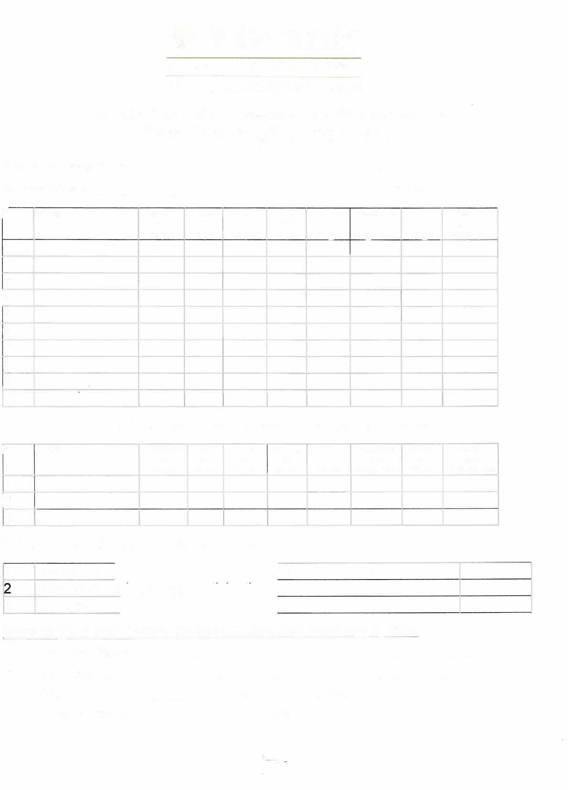
Kiwanis·
MISSOURI-ARKANSAS DISTRICT

EARL COLLINS FOUNDATION
2023-2024 Earl Collins Kiwanis Foundation Scholarship
Club Grading/Rating Form
President's Signature Date
Kiwanis Club of Division
#7

�  1 | NAME | Achieve #1  35 ots | Vol #2  15 ots | Honors #3  10 ots | Career #4  10 ots | Letters Fin/Need #5 #6  10 pts 20 pts Plus |  | Bonus  10 pts | Total 1  thru 7  110 ots olus
2
3
�
5
6
7
8
9 | I | ,
10 | :
List Three Club Finalists in rank of order by points scored
#5

# NAME |  | Achieve #1  35 pts | Vol #2  15 pts | Honors Career  #3 #4  10 pts 10 pts |  | Letters  10 pts | Fin/Need  #6  20 pts Plus | Bonus  #7  10 pts | Total 1  thru 7  110 ots olus
1
2
3
SCHOLARSHIP APPLICATION INFORMATION
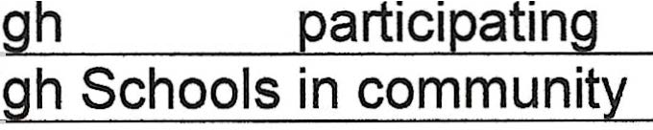
1
Number of a Number of Hi Number of Hi
Schools
our Kiwanis Club
3
Send to your Earl Collins Division Trustee by February 9, 2024:
Trustees Name:
Address:
City: State: Zip Code:
Phone Number: Email:

Kiwanis·
MISSOURI-ARKANSAS DISTRICT

EARL COLLINS FOUNDATION

EARL COLLINS FOUNDATION CONTRIBUTION FORM
The Earl Collins Foundation of the Missouri-Arkansas Kiwanis District of Kiwanis International was originally the Earl A Collins Memorial Scholarship Fund. Establishment of the scholarship fund was approved during the 1960 Missouri­ Arkansas District Convention in Saint Joseph, Missouri, to perpetuate the memory of Dr. Earl A Collins, an educator, Past Governor and Secretary of the Missouri-Arkansas Kiwanis District.
As a Kiwanian, Dr. Collins was a charter member of the Cape Girardeau Kiwanis Club and served as Missouri-Arkansas Governor in 1952. During his administration, the decision was made to have the first Mid-Winter Conference in Springfield, Missouri, in February of 1953. 190 Kiwanians attended the first meeting and since it was a success, the Mid-Year, as it is presently known, is a vital part of the Missouri-Arkansas District's annual activities. Dr. Collins was the first salaried district secretary and KIWANIGRAM editor, serving in this position from 1956 until his death in 1960.
When the scholarship fund was established soon after his death, it was suggested that each Kiwanis Club in the District contribute $1.00 per member to the fund with the interest to be given to deserving students attending Southeast Missouri State College. The recipients of the scholarships may now attend the college or university of their choice. For several years the scholarship was in the amount of $500.00 to 27 high school seniors from the Missouri-Arkansas Kiwanis District. Beginning in the 2002-2003 academic year 23 the scholarships for $750.00, were awarded to high school seniors from the Missouri-Arkansas Kiwanis District. Starting in the 2013-2014 academic year scholarships for $1,000.00 have been awarded in each division of the Missouri-Arkansas District.
Currently, each Kiwanis Club contributing $5.00 per member receives a banner patch to signify the club's contribution and desire to make an investment in the leaders of tomorrow. Individuals are also encouraged to make contributions to the fund as a triQute or memorial to honor Kiwanians, friends, family, or associates of Kiwanians.
With the sudden death of Arnold Zimmerman, Jr., the ECF Board decided to honor "Zim" by creating the Arnold W. Zimmerman, Jr. Society of the Earl Collins Foundation, established in "Zim's" honor. A club or individual is named a "Zimmerman Society" member by contributing at least $250.00 per year over a maximum period of four years. Also, a lump sum contribution of $1000.00 will qualify for the "Zimmerman Society" program.
The Les Mace Fellowship award is unique in that it was designed to present to Kiwanians and non-Kiwanians in recognition of their service to their clubs and community. The award cost is $150.00 per recipient who will receive an 8" x 10" plaque with their name, sponsoring club or person with date of presentation. The donor can designate up to
$100.00 donation to a MoArk sponsored program, with the remaining $50.00 to cover the cost of the plaque, or any other costs.
Contributor: Kiwanis Club of: Division

Kiwanis Club# Members: x $5.00 = Amount contributed $

I (we) would like to become a member of the: Fellow or the Arnold W. Zimmerman Society
□ □
a check for $1,000 is enclosed or a check for $250 is enclosed.

Name of individual Kiwanis Club

Mailing address City and State Zip Code Please send contributions to:
John Buckwalter, Secretary, Earl Collins Foundation, 2602 N. New, Kirksville, MO 63501

