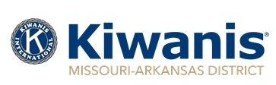

2023-2024 Distinguished Club Criteria
Missouri-Arkansas Kiwanis District
Must Have Completed:
- The Club must have a net increase in membership of at least two members. The invoice the club pays to Kiwanis in October 2024 must contain at least two more members than the invoice paid in October 2023.
- The club must have appointed a Membership Chair and Public Relations Chair.
Must have completed at least five of the following:
- Sponsor or co-sponsor a new Kiwanis Club or a new Service Leadership Program. If so what was it?
- Both the club’s President and Secretary attended Club Leadership Education either in person or online before September 2023.
- Club was represented by a member at one of the following: District Mid-Year Retreat, District Convention, or the Kiwanis International Convention and at least one Division or Region Meeting.
- Club provided service projects or programs for the children of the community.
- Club supported and donated to the Kiwanis Children’s Fund.
- Club sponsored a Service Leadership Program.
- Club contributed to the District Outreach Fund or to at least one of the following: The Earl Collins Foundation, the Beatrice Johnson Kiwanis Youth Kamp Foundation, or Key Leader.
- Club had an interclub with at least 75% of the clubs in their division.

