Kiwanis Club of [Name]
Annual Pennsylvania Kiwanis Foundation Rose Sale

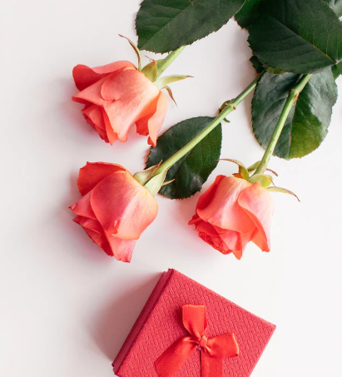
Your purchase includes one dozen quality long-stemmed roses of mixed color. Each dozen is $29 and includes tree fern and baby’s breath packaged in a box that makes for a perfect gift. A portion of each sale benefits local Kiwanis community projects as well as the Pennsylvania Kiwanis Foundation’s mission of providing service grants and scholarships to youth.
• Orders may be placed until [Wednesday, September 30]
• Roses will be delivered starting Wednesday, October 28th
• [Indicate here how you prefer to accept payment – cash, checks, etc…]

Club Member Name: __________________________ Phone: ____________
Total # Sold: __________ Total due of all Sales: ___________

# | Name | Address | Phone | # of Dozens | Total Due | Paid?  (Yes/No) | Payment
1 |  |  |  | [Delete this box before saving and printing]  Customization Notes:  Customize flyer by editing any information in the brackets [ ]  [Delete this box before saving and printing]
2
3
4
5
6
7
8
9
10

11

12

13
14
15
16
17
18
19
20
21
22
23
24
25

