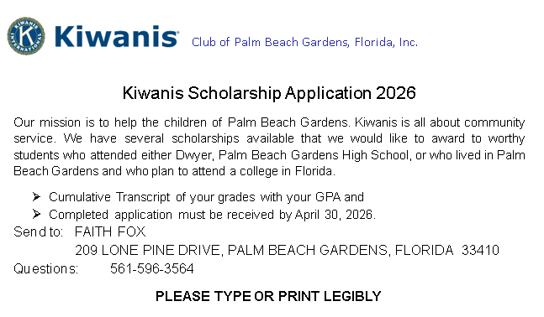

- Personal Information.
Name of Applicant: ________________________________________________
Address: ________________________________________________________
Telephone: _______________________________________________________
Email: ___________________________________________________________
Name of High School: ______________________________________________

- School & Community Activities
List school extracurricular activities and any offices held, or awards received. Please state years of participation:
________________________________________________________________________________________________________________________________________________________________________________________________
Community Service Hours: __________________

List community service activities within Palm Beach Gardens or your Town/City where you reside. Please describe details and years performed.
________________________________________________________________________________________________________________________________________________________________________________________________________________________________________________________________________________________________________________________________________________________________________________________________________________________________________________________________________________________________________________________________
Check here if you are in a Kiwanis sponsored Key Club: _____

List any other activities within or outside Palm Beach Gardens or your Town/City where you reside that you feel may be important to your candidacy.
________________________________________________________________________________________________________________________________________________________________________________________________________________________________________________________________________________________________________________________________________________________________________________________________________________________________________________________________________________________________________________________________

- Academic Status & Educational Plans
What is your current class rank and grade point average?

What school are you planning on attending? List pending applications if not yet accepted.
________________________________________________________________

Have you declared a major course of study? If so, please note here.

What are your career plans and goals?
________________________________________________________________________________________________________________________________________________________________________________________________________________________________________________________________________________________________________________________________________________________________________________________________________________________________________________________________________________________________________________________________________________________________________________________________________________________________________________________________________________________________________________________________________________________________________________________________________________________________________________________________________________________________________________________________________________________________________________________________________________________________________________________________________________________________________________________________________________________________________________________________________________________________________________________________
