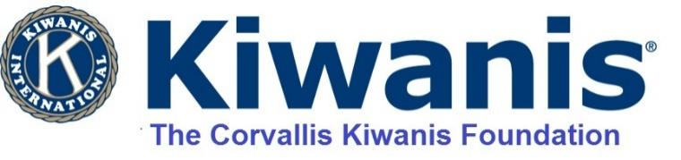

APPLICATION FOR FUNDING SUPPORT
2025/2026

Brief description of what the funding is for. You may include a one-page summary of your Project and/or your organization with this application.
______________________________________________________________________________
______________________________________________________________________________
______________________________________________________________________________

Name of Organization: _________________________________________Date: _____________

Person and Title making Application: _______________________________________________

Phone: ________________

E-mail address (please write clearly): _______________________________________________
Address of Applicant: ____________________________________________________
City: ________________________ Zip Code: ____________

Are you a Non-Profit Organization? Yes_____ No ____
Your Non-Profit EIN Number: ________________________

If you are not a 501c3 not-for-profit are you partnering with one for this request? Yes___ No___
If Yes, what is the agencies name and EIN#__________________________________________
_____________________________________________________________________________

We prefer not to support general budgets, rather programs or needed items. If this request is in support of a general budget, please provide a copy of your budget.

Amount being requested $____________ If for a Project, total budget? $______________

Have you applied for support of this project from one of our two Corvallis Kiwanis Clubs or one of their committees in the last year (Oct. 2024- Sept. 2025)? Circle- Yes or No.
If “yes” how much did you receive? $_________________________ .

Do you receive Federal Funding for your organization? If so, what percentage of your budget is federally supported?

Other sources of funding for your Project? Please attach a list.

We are a rather small Benton County foundation and we do understand that some organizations provide services in both Benton & Linn Counties. Please provide the number of individuals and the percentage of people served in Benton or Linn County who will benefit from this grant request? ______________________________________________________________________________

Date funding is needed? ___________ Expected Project completion date? ________________

Send Application to: The Corvallis Kiwanis Foundation
℅ Thomas Kiersky
5300 NE HWY 20
Corvallis, OR 97330

E-mail Application or questions to: tkiersky@gmail.com

APPLICATIONS WILL NOT BE ACCEPTED LATER THAN DEC. 15, 2025

Please report back the success of your project no later than Sept. 1, 2026

The Corvallis Kiwanis Foundation is a 501(c)3 nonprofit organization
EIN 23-7293911

