66th HOLLAND KIWANIS CLUB
HOLLAND TULIP FESTIVAL
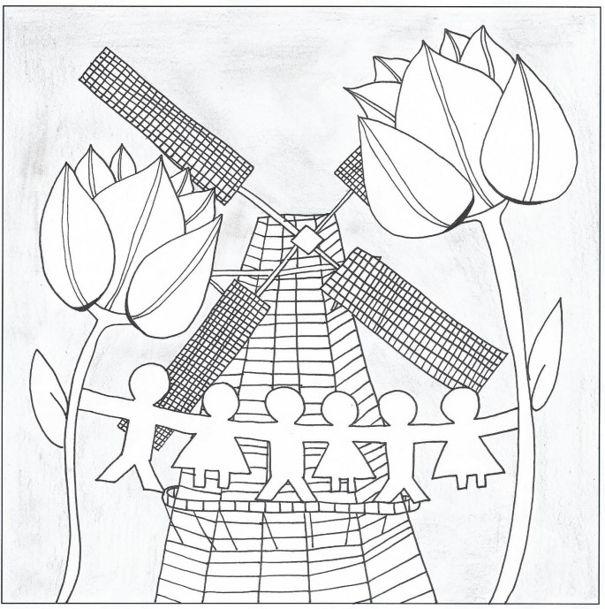
CHILDREN PRIORITY ONE
Sponsored by
The Kiwanis Club of Holland
We are Proud of 71 Years of Service to our Community and to our World!
Our Title Sponsor is The Bank of Holland
May 11th, 12th, & 13th, 2023
(The Tulip Festival is ALWAYS the second weekend in May!)
Special Acknowledgements:
WXRL Radio 1300 AM and 95.5 FM
Roadhouse Tattoos
Holland Eye Center
Holland Chiropractic
Route 16 Wine and Liquor
Holland Central School District
Holland Board of Education
The Town of Holland
The Holland Fire Department
The Queen and her mother will enjoy a weekend trip courtesy of the
Kiwanis Club of Holland

Thursday, May 11th

Holland Tulip Festival Senior Citizens Breakfast
St. Joseph’s R.C. Church, N. Main St. 9:00 to 10:00 AM

Upstate Automotive Group
Car Show, Barbecue, food, beverages
on Main St. 4:30 to 7:00 PM

Talent Show Dress Rehearsal
High School Auditorium 7:00 PM, Admission $3.00, Senior Citizens free

…………………………………………………….

Friday, May 12th

School Art Show
High School Lower Lobby

Spirit Parade
Elementary School Drive, 1:45

Carnival, Food, Games, Music by Kiwanis Club of Holland
Town Parking Lot 4:00 to 10:00 PM, Beer Tent 6:00 to 10:00
with the Steve and Gary Edmonds Duo

Holland Garden Club Flower Show
Theme: “Wizard of Oz” at the Holland Community Center 7:00 to 9:00 PM

Queens Pageant and Talent Show
With a performance by Mr. Holland, Alex Weich
High School Auditorium, 7:00 PM. Admission $5.00, children under 12, $3.00

Saturday, May 13th
The 27th Annual 5K Fun Run/Walk
Sponsored by the Bank of Holland
All proceeds to benefit the Boys & Girls Club of Holland. Start time and same day registration at the Holland Community Center, 3 Legion Drive. All race parking at the Elementary School. Registration @ 7:30 a.m., race starts at 9:00 a.m. Registration fee-$30 for adults (19 years old & above); $15 for students (5-18 years old); under 5 years old is free; before May 11th. After May 11th-$35 and $20. For details and registration info visit the Boys & Girls Club of Holland website (www.bgcholland.org) or stop by the Bank of Holland.

The HUGE Arts and Crafts Show
High School, 9:00 AM to 4:00 PM

Fire Department Crash Extraction Demonstration
Town Hall Parking Lot 10:30

School Art Show
in the High School Lower Lobby

WXRL (AM 1300, FM 95.5) Live Remote Broadcast
In front of the High School 10:00 AM to 1:00 PM

Holland Historical Society Exhibits
7 South Main St., 10:00 AM to 3:00 PM

Carnival, Food, Games, Music by Kiwanis Club of Holland
Town Parking Lot 11:00 AM to 10:00 PM, Beer Tent 4:00 to 11:00
with HIT N RUN, Buffalo’s Premier Party Band

The Holland Garden Club Flower Show
Theme: “Wizard of Oz” at the Holland Community Center 10:00 AM to 5:00 PM

The Big Tulip Festival Parade starting @ 2:00 PM
Theme: “Children Priority One” Marching Bands and Floats,
Live Broadcast on WXRL AM 1300 & FM 95.5
Sponsored by the Holland Eye Center, Roadhouse Tattoos, Holland Chiropractic,
And Route 16 Wine and Liquor

Coronation of the 2022 Tulip Festival Queen
High School Auditorium (note new time!) 6:00 PM, admission $3:00
YOUR 2023 TULIP FESTIVAL QUEEN CANDIDATES!
Cate Youngers Chloe Conrad Abigail Suplicki Anna Tavernier

Brianna Cottrell Maggie Shafer Lexi Porter
Taylor Thomson Skylar Metzger Ella Szucs Masyn Perrigo

Proceeds are used for the charitable activities of the Kiwanis Club of Holland
OUR TITLE SPONSOR IS THE BANK OF HOLLAND

