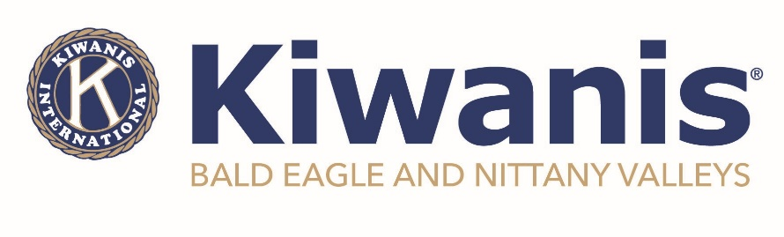
For Immediate Release
April 12, 2022

BENV Kiwanis Announces 3rd Annual Essay Contest

Clinton County – The Kiwanis Club of Bald Eagle and Nittany Valleys is pleased to announce the opening of their third annual student essay contest. The contest is open to all children living within the Keystone Central School District boundaries. Additionally, a senior who will be moving on to post-secondary education will receive a $500 scholarship.

This year’s theme will be “Kindness”. The world in general can always use more kindness, and the students are asked to answer the questions: How does kindness affect our community? How does kindness affect our physical and mental health? What can BENV Kiwanis do to promote more kindness in our community? What random acts of kindness would you like to see more of?

“We’re excited to be sponsoring this contest for it’s third year and pleased to be able to increase the scholarship amount,” said Sally Young, chairperson of the contest. “The last two themes focused on the pandemic and the entries provided us with the insight we were hoping for to better serve our community – this year’s theme puts a positive spin on the contest, and we are looking forward to gaining additional knowledge from these entries.” She added; “K stands for Kindness, Kiwanis, and Kids.”

The contest runs from April 4th until May 15th and prizes will be awarded according to age group. More information on the contest, including how to submit entries, can be found at www.kiwanisofbenv.org. For those younger students, artistic creations are encouraged in place of, or in addition to, the essays. Winners will be announced on June 1st on the BENV Facebook page and later posted to their website.

Chartered in 2012, the Kiwanis Club of Bald Eagle and Nittany Valleys is dedicated to making the world a better place by providing opportunities for children, youth, and their families. If you are interested in more information on how you can be part of the organization, please contact us today.

###

