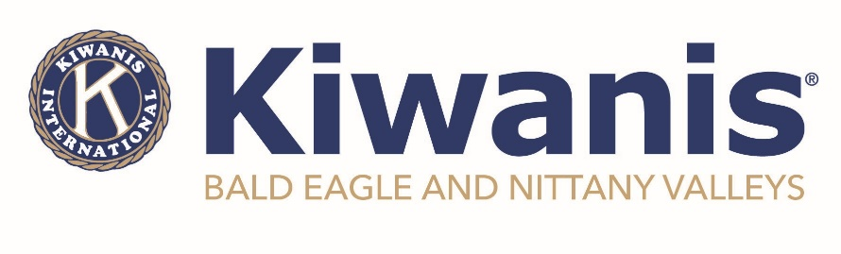
For Immediate Release
October 14, 2023

BENV Kiwanis seeks donations for Backpack Project

Clinton County – The Kiwanis Club of Bald Eagle and Nittany Valleys is looking for the community’s assistance in providing items for their on-going backpack project. Now in its third year, the backpack project provides area foster children and those experiencing homelessness with a bag filled with useful and needed items. The club will be collecting items for the backpacks and is partnering with the Keystone Cares initiative for their November theme relating to awareness of homelessness in our community.

“Often times, when children find themselves being placed in foster care or being removed from their home last minute, they may not always have the access to certain items that may help make a difficult situation a little better,” said Della Watson, project coordinator. “Our goal with this project is to pack each bag with toiletries, activities, pajamas, books, and more.”

The BENV Kiwanis Club will accept donations of shampoo and conditioner, body wash, deodorant, hair brushes or combs, hair accessories, school supplies, journals, activities, warm socks, gloves, and hats to add to their bags. If you are interested in donating, there is a drop box at Miller Brother’s Auto Sales in Mill Hall or you can contact the club directly via email at benvkiwanis@gmail.com. All bags will be given to children who have been identified in need by the school district and/or Clinton County Children and Youth. For those interested in assisting in the backpack project, the club will be putting the items together on Wednesday, November 15th at 6:00pm on the second floor of the Sons of Italy in Lock Haven.

Chartered in 2012, the Kiwanis Club of Bald Eagle and Nittany Valleys is dedicated to making the world a better place by providing opportunities for children, youth, and their families. If you are interested in more information on how you can be part of the organization, please contact us today by visiting www.kiwanisofbenv.org.

###

