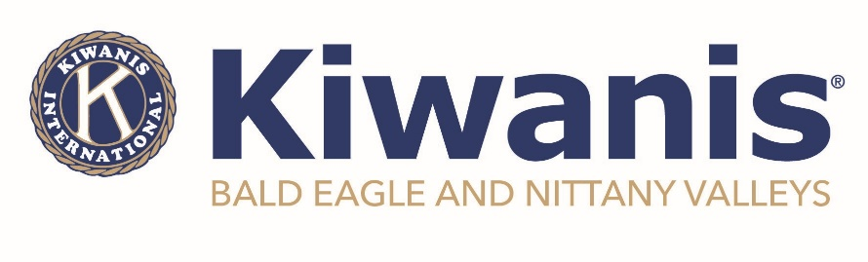
For Immediate Release
July 16, 2024

MILL HALL - The Kiwanis Club of Bald Eagle and Nittany Valleys recently held their 12th Annual Kids Day at the Mill Hall Fire Hall on Saturday, July 13th. Approximately 100 children and their families weathered the heat wave and stopped by to visit, learn, play, and have fun! Welcomed by Smokey Bear, the participants were able to meet with various state and local agencies, all with a common theme of serving our children and families. After going through the expo-style setting, they were directed to visit the craft and game area, grab a snack, visit with Mikey the pony from Horses of Hope, or go on a barrel train ride through the Mill Hall Park. At the end, prizes were drawn for various educational material, games, toys, and bicycles. Midway through the event, guests were treated to a special performance from Millbrook Playhouse, a first for Kids Day.

"Even though there were several other community events happening, we are thankful for those who stopped by for a visit", said Penny Meyers, event chairperson. She added that "our team did an exceptional job pulling this together and put a lot of time and effort into it, but when you see the smiles on some of those faces, it makes it all worthwhile."

Club Treasurer, Sally Young, observed that "the flow of the event was great this year and it wasn't overcrowded - allowing the exhibitors and Kiwanis members to spend more time with each child at the stations to give them the experience they were looking for and deserve."

Chartered in 2012, the Kiwanis Club of Bald Eagle and Nittany Valleys meets on the first Wednesday of every month at 6:00pm on the third floor of the Sons of Italy in Lock Haven. For more information on meetings, programs and events, or membership, please visit www.kiwanisofbenv.org or www.facebook.com/BENVkiwanis.

Photos Attached

###

