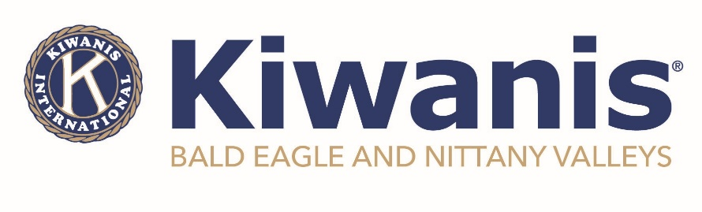
For Immediate Release
August 6, 2024

BENV Kiwanis donates to local organizations

MILL HALL - The Kiwanis Club of Bald Eagle and Nittany Valleys presented two donations to community organizations during it’s recent Kid’s Day. Both Millbrook Playhouse and Sleep in Heavenly Peace each received a monetary donation of $200 toward their programming.

“The support of Millbrook Playhouse, especially their youth ensemble, is an important aspect of the development of young children,” said Matt Wise, BENV President. “It is important to support their efforts.” The funds go toward their youth ensemble, which gave a special performance of Mean Girls at the annual event.

Sleep in Heavenly Peace, a national organization with a local presence was the second beneficiary. “We have supported SHP for several years and each time we are amazed at the need they are meeting in the community,” added Penny Meyers, BENV Secretary and Young Children: Priority One co-chair. “They’re providing something that many of us find to be just a regular part of life – a comfortable, safe, and warm bed – no child should go without a bed.”

Chartered in 2012, the Kiwanis Club of Bald Eagle and Nittany Valleys meets on the first Wednesday of every month at 6:00pm on the third floor of the Sons of Italy in Lock Haven. For more information on meetings, programs and events, or membership, please visit www.kiwanisofbenv.org or www.facebook.com/BENVkiwanis.

Photos Attached

###

