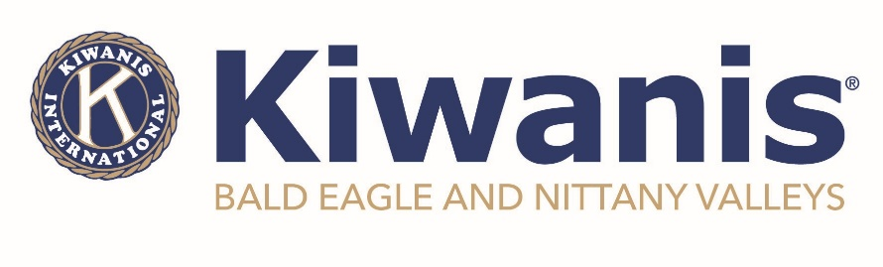
For Immediate Release
September 24, 2024

BENV Kiwanis Recognizes Members, New Leaders

MILL HALL - The Kiwanis Club of Bald Eagle and Nittany Valleys recognized several members for their work over the past year. Their year runs from October 1 to September 30. Outgoing President, Matt Wise, presided over the Olympic-themed event, thanking the Membership Experience Committee for their work at making the end-of-year celebration a complete success.

“It is fitting that we recognize our super stars with an Olympic-themed event this year,” said Wise. Adding that “all of our members deserve recognition for the work that they do in the community, but it is always nice to showcase specific members throughout the year.”

Also, as part of the evening, Wise ceremoniously turned over the gavel to incoming President Ricky Reinberg, adding that he was “proud of the members of the BENV Kiwanis because of the many positive impacts the members have made in the Clinton County region”, thanking each and every member for their contribution for the year and wishing Reinberg luck as he prepares to lead the 12-year old organization. Reinberg stated that there will be a formal officer installation ceremony to follow at a later date.

The recipients of this year’s awards are as follows:

Community Connections – Tia Walker
Having served in numerous leadership roles, she also represents Kiwanis at many public events and functions. Even though she attends these events in a professional capacity, she is ALWAYS talking about Kiwanis and encouraging others to join. She has sponsored several new members into our club and never misses an opportunity to identify someone who would make a great Kiwanian – all from various parts of our community. She is a wealth of knowledge and does everything without the need for credit or recognition…just the reason why she should be recognized tonight.
Service – Amy Strong

Amy has really started to take the lead on several things in the club since joining. Her ideas are fresh and valuable and she is not afraid to offer ideas and solutions. In addition to her fresh ideas, she encourages others to be creative and think outside of the box. Perhaps even in new boxes.
Commitment – Penny Meyers and Linda Walker

This award goes to a dynamic duo. Not only do they serve in leadership roles, but they also do a lot of behind the scenes work getting ready for our larger (and some smaller) events. Why? Because they have time and because they can. Not because they have a feeling that the HAVE to, but because they want to. They’ve even worked with other, newer members to bring them into this group of “do’ers” and we will see a much more well-oiled machine in the coming year. This list could be endless, but this duo is deserving of a special shout-out this year.
Partnership – Holly Eisamann

Holly has shown her commitment to the children in the community as she provides creative programs at Kiwanis functions. Recognized by one of the community youth participants in our essay contest, she approaches everything she does with passion and dedication. The brains behind our newest Builders Club and someone who is always willing to give it her all to make a name for Kiwanis and show the benefits of partnerships in our community, Holly is a Rock Star.
Compassion – Laural Zerbe

Ever since joining, Laural has been a positive asset to BENV Kiwanis. Her passion and commitment in every meeting she attends is contagious. She approaches each situation with compassionate thought and provides meaningful advice and guidance to the board and our members. With great ideas, she is always willing to share her passion for Kiwanis.

Chartered in 2012, the Kiwanis Club of Bald Eagle and Nittany Valleys meets on the first Wednesday of every month at 6:00pm on the third floor of the Sons of Italy in Lock Haven. For more information on meetings, programs and events, or membership, please visit www.kiwanisofbenv.org or www.facebook.com/BENVkiwanis.

Photos Attached

###

