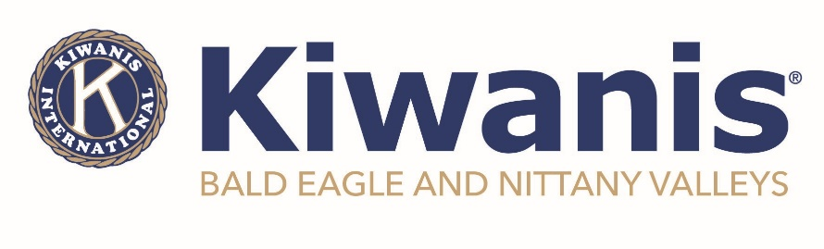
For Immediate Release
September 24, 2024

LOCK HAVEN - The Kiwanis Club of Bald Eagle and Nittany Valleys is pleased to announce the official chartering of the Ross Library Builder’s Club, which will be led under the direction of Miss Holly Eisaman, a BENV member and Ross Library Children’s Librarian.

Builders Club is a Kiwanis Service Leadership program for the middle years/middle school age students. Club members learn about their interests and talents as they make friends and develop a passion to serve, skills to lead, and the ability to engage and collaborate with others.

“We are excited to charter the Ross Library Builders Club”, said Matt Wise, BENV Club President. “With the leadership of Miss Holly, we are fortunate to have such a meaningful program to share with the kids, and the kids are even more fortunate because we could not ask for a better advisor than Holly!”

The Builders Club operates under local regulations and draws its members from the community and users of the Ross Library. Any student who is of middle school age is welcome to join. It is the largest service organization for middle school and junior high students with more than 23,000 members worldwide. Those interested in joining can contact Miss Holly at 570-748-3321 or ross9@rosslibrary.com.

“I am super excited to see the great things these kids are doing,” said Eisaman. “Right now, we have a great start and I know that they’ll do spectacular things once we get this moving in an even more positive direction!”

Chartered in 2012, the Kiwanis Club of Bald Eagle and Nittany Valleys meets on the first Wednesday of every month at 6:00pm on the third floor of the Sons of Italy in Lock Haven. For more information on meetings, programs and events, or membership, please visit www.kiwanisofbenv.org or www.facebook.com/BENVkiwanis.

Photos Attached

###

