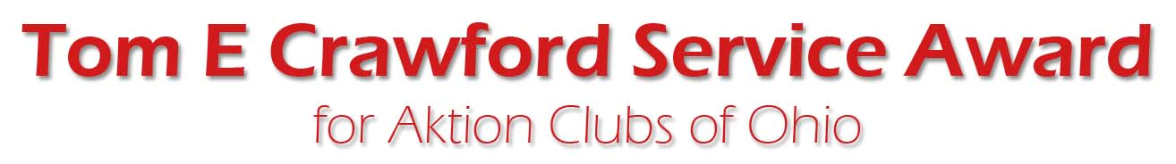

Sponsored by the All Ohio e‐Medina Kiwanis Club

The All Ohio e‐Medina Kiwanis Club along with Tom Lou Crawford are pleased to sponsor the Tom E Crawford Ohio Aktion Club Service Award.

The award is named after Kiwanian Tom E Crawford and is awarded annually for the "Best overall service project" by an Ohio Aktion Club during the current Aktion Club year.

Please answer the following questions with a sentence or two and return via e‐mail or "snail" mail with a stamp postmarked by July 12.

1. What was your service project? Give a brief description.

2. If money was raised, how did your club do it?

3. Who was helped? What was improved?

4. How many Aktion Club members were involved?

5. What did your club do to inform the community and Kiwanis family about the project?

6. What did Aktion Club members learn as a result of participating in this project?

7. Will this be a continuing project?

Entries will be judged by the award committee and the plaque will be presented at the Convention.

e-mail entries to: Dick Brulotte, AktionClub@ohiokiwanis.org

Or
put the entry in an envelope addressed to:
Tom E Crawford Aktion Club Award
c/o Richard Brulotte
217 Jay Court
Delaware, Ohio 43015

Entries must be postmarked or e-mailed by July 12.

