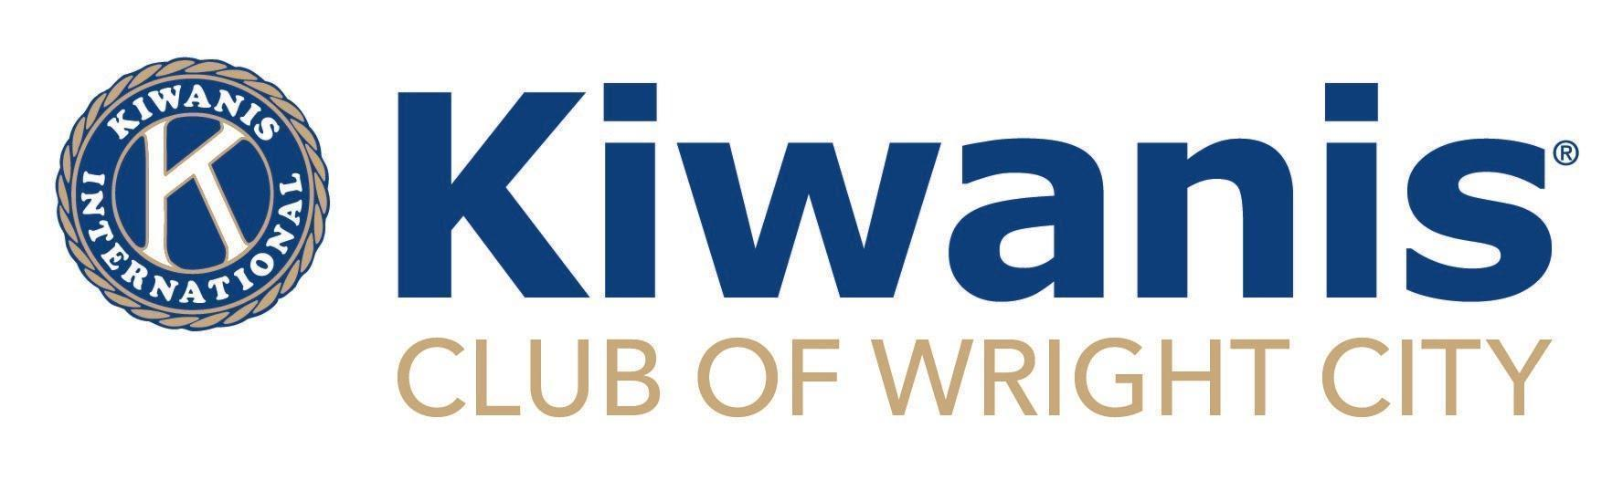

Meeting Agenda
Date: October 5, 2022
Call to order: _____________
Pledge
Prayer
Object 6: To cooperate in creating and maintaining that sound public opinion and high idealism which make possible the increase of righteousness, justice, patriotism, and goodwill.
· Kiwanis members believe in the high ideal of standing up for what is right.

Welcome and recognize any Guests -

Birthdays for this Month: Rhonda Wallace Oct 15 Donna Survant Oct 20
Ed Radginski Oct 24

Membership - (31 members)

Mail from PO Box -
Happy Sad $$

- Key Club – Brief report

- Boys & Girls Club – (Holly Breakfield)

OFFICER INSTALLATION: (Lt Governor Tiffany Ermeling)
Board Members - Aaron O’Neal, Michelle Smith, Sue Wright, Brittany Rody
Treasurer - Karen Girondo
Secretary - Martha Radginski
President-Elect - Kayleigh Baryo
Immediate Past President - Mary Groeper
President - Jenn Olivio

UPCOMING EVENTS:
- Strassenbash- Discussion

- Pancake Supper (Nov 4th) – Tickets will be distributed today

- Books & Bingo (Nov 5th) - Sign up online at wrightcitykiwanis.org

- Grants – Update?

- Kiwanis Sports Closet - Open Wednesday 5:00-7:00pm. Hours changed for Saturdays. Now open 10:00am to 12:00pm
We Need Your Help - please sign up for a shift today!

- Other?

Community News/Events:

Next Club Meeting will be on: Wednesday, November 2 - 12:00 - WC Library

Next Board Meeting will be on: Monday, October 17 - 3:30 PM - WC Library

Meeting Adjourned: ____________

