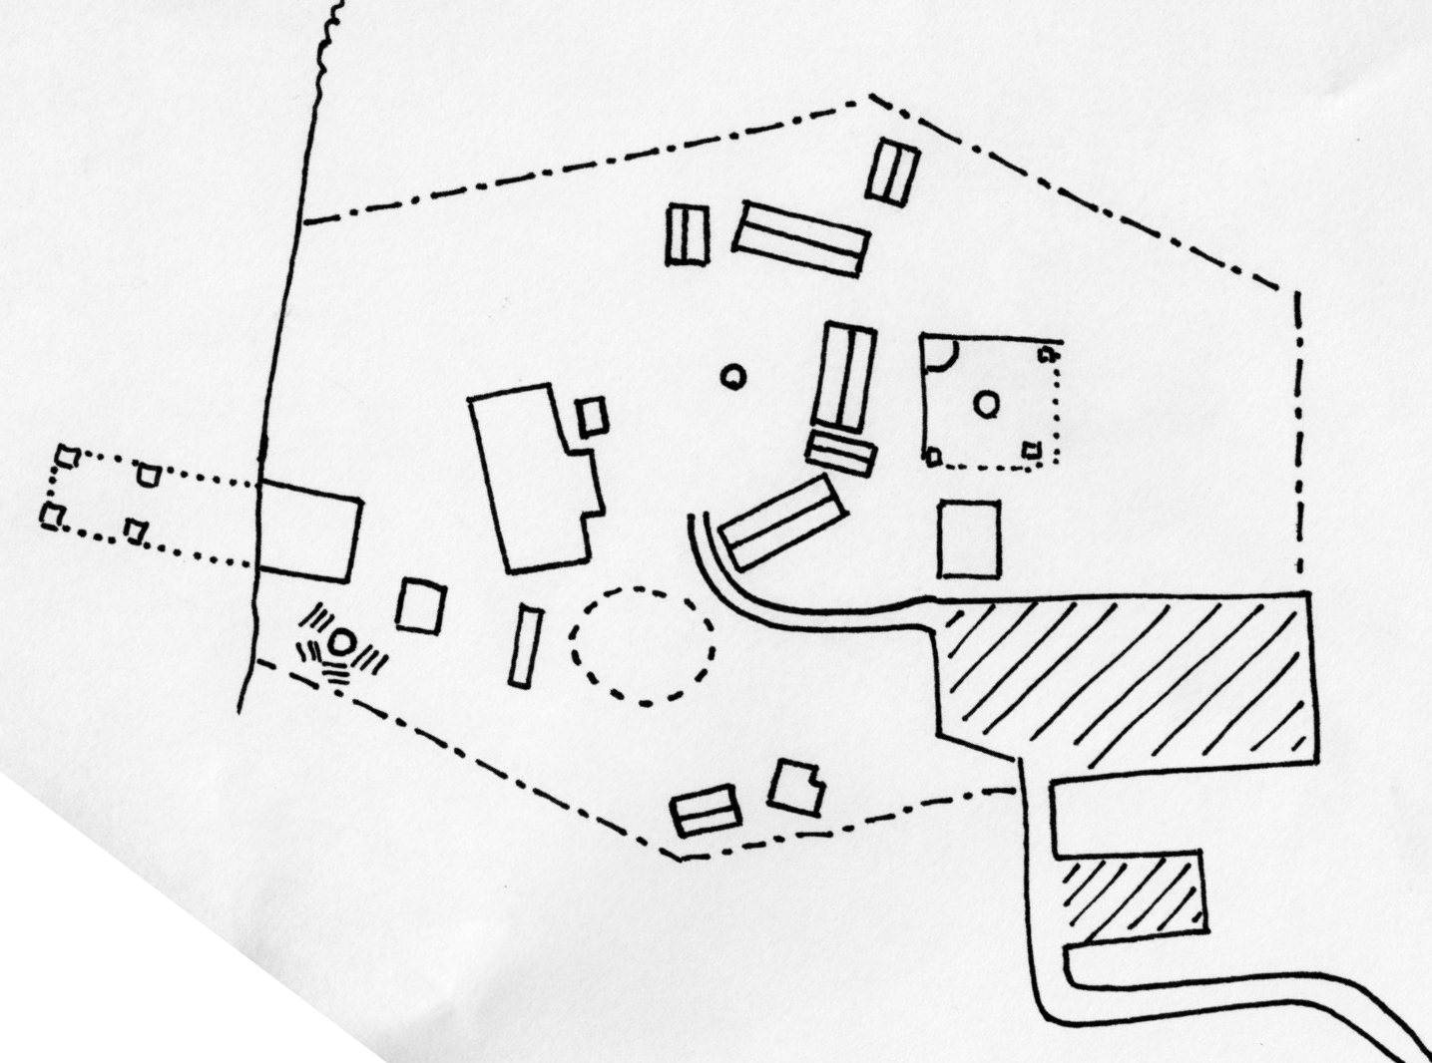

**3 Dorms sleep 40 each**

**2 Cabins sleep 4 each**

**1 Apt. sleeps 4**

**Total Beds 132**

Beach and Swim Area

Volleyball

Fire Ring & Benches

Horseshoes

Playground

Dorm Apt. (sleeps 4)

Rental Cabins

Sleep 4 each)

Caretaker’s House

Dorms (sleep 40 each)

Dining Pavilion

Camp Entry Road

**Camp Kiwanis Facilities**

Basketball Court

Baseball Diamond

Parking

Parking

**Mill Dam Lake**